Database Design and Implementation

Faculty: Science and Technology

Department: Computing and Technology

Academic Year: 2023/24

Trimester: 1

Contents

1 Requirement Analysis (15%) 4

1.1 Description of the three websites chosen 4

1.1.1 https://ao.com/ 4

1.1.2 https://www.appliancesdirect.co.uk/ 5

1.1.3 https://www.ikea.com/ 5

1.2 List of data fields (Entities and their attributes) 5

1.2.1 List of data fields from website 1 6

1.2.2 List of data fields from website 2 13

1.2.3 List of data fields from website 3 19

1.3 Finalised List 25

2 Database design (25%) 27

2.1 Entity Relationship Modelling 27

2.1.2 Extended Entity Relationship Model 27

2.2 Database Schema 29

3. Database implementation (10%) 39

4. SQL Queries (50%) 50

4.1 Query 1 50

4.1.1 For what purpose will this query be used in business terms? 50

4.1.2 Query in natural language 50

4.1.3 SQL Code and output 50

4.1.4 Explain the output of the data (was this what was predicted?) 54

4.2 Query 2 54

4.2.1 For what purpose will this query be used in business terms? 54

4.2.2 Query in natural language 54

4.2.3 SQL Code and output 54

4.2.4 Explain the output of the data (was this what was predicted?) 55

4.3 Query 3 56

4.3.1 For what purpose will this query be used in business terms? 56

4.3.2 Query in natural language 56

4.3.3 SQL Code and output 57

4.3.4 Explain the output of the data (was this what was predicted?) 58

4.4 Query 4 58

4.4.1 For what purpose will this query be used in business terms? 58

4.4.2 Query in natural language 59

4.4.3 SQL Code and output 59

4.4.4 Explain the output of the data (was this what was predicted?) 61

4.5 Query 5 62

4.5.1 For what purpose will this query be used in business terms? 62

4.5.2 Query in natural language 62

4.5.3 SQL Code and output 63

4.5.4 Explain the output of the data (was this what was predicted?) 66

5. References 67

# Requirement Analysis (15%)

## 1.1 Description of the three websites chosen

In the present digital era, internet shopping has become a vital part of our everyday lives by delivering convenience, variety, and competitive cost. To delve into the e-commerce scene in the field of appliance buying, notably for refrigerators, this investigation digs into three important commercial websites recognised for their online purchase capabilities. These websites have been carefully selected for their reputation, popularity, and user-friendliness, ensuring a comprehensive examination of the interactive pages and fields required for purchasing fridges.

As the task unfolds, we will explore and document the process taken on each of these websites, paying close attention to the fields that must be completed by the purchaser during the online purchase process. This analysis aims to provide valuable insights to later provide a final provisional database design based on appliance shopping, particularly for refrigerators, by offering a detailed view of the user experience and purchase requirements on these well-established e-commerce platforms.

### <https://ao.com/>

Ao.com is an online marketplace that sells a range of electronic products. It offers products such as appliances, TV and entertainment, computing, mobile phones, smart tech, and floorcare. The company was founded in 2000 and is headquartered in Bolton.

### <https://www.appliancesdirect.co.uk/>

Appliancesdirect.co.uk is an online commerce website that is one of “Uk’s leading appliance retailers”. (Trustpilot,2021) They offer a vast range of products at competitive prices. The company is a division of the Buy It Direct Group which began in 1999 and later acquired the company in 2008. (AppliancesDirect, 2023).

### <https://www.ikea.com/>

IKEA is a company that designs and sells many kinds of ready to assemble furniture, home accessories and kitchen appliances. (Ikea, 2018)

## List of data fields (Entities and their attributes)

Listed below are 3 lists of data fields that have obtained by scrutinizing the process taken to successfully purchase a fridge on each of the websites. The process involved first creating an account to each respective website followed by selecting the fridge category within the website. After doing so a subcategory is chosen. From there the customer can select the product(s) of their choice, add to basket and choose the add-ons to the specific product and later continue with the payment method of choice.

Whilst doing this it became clear that AO and appliances direct were far more detailed in terms of product descriptions shown and the overall amount of user options the customer can make whilst choosing their desired fridge(s) compared to ikea . This is due to IKEA being more furniture based rather than appliance based so there is less variety issued to the customer. The following sub sections will delve more into that and illustrate the differences and similarities of all the sites to give a finalised list of data fields of entities and attributes that are going to be implemented in the database.

|  |  |  |  |
| --- | --- | --- | --- |
| **Customer Information** | **Product Details** | **Basket** | **Payment and Order** |
| Join AO Five Star | Product Title | Quantity | Expiry Date |
| Title | Colour | Title | Security code |
| Email | Price | Unpack | Name on card |
| First Name | Brand | Basic Installation bundle | Does your billing address the same as your delivery address? |
| Last Name | Product information | Continue | Confirm order and pay |
| Mobile Number | Product Quantity | Discount code | PAY WITH AO Finance |
| Alternative Number | Product code | Previous Price | PAY WITH PayPal |
| Postcode |  | Total Price | Credit card number |
| HouseNumber/name |  | Connection only | Postcode |
| Address line 1 |  | Remove and recycle | Email Basket |
| Address Line 2 |  | unpack | Security code |
| County |  | Door reversal |  |

### List of data fields from website 1

Table 1: List of data fields extracted from AO website.

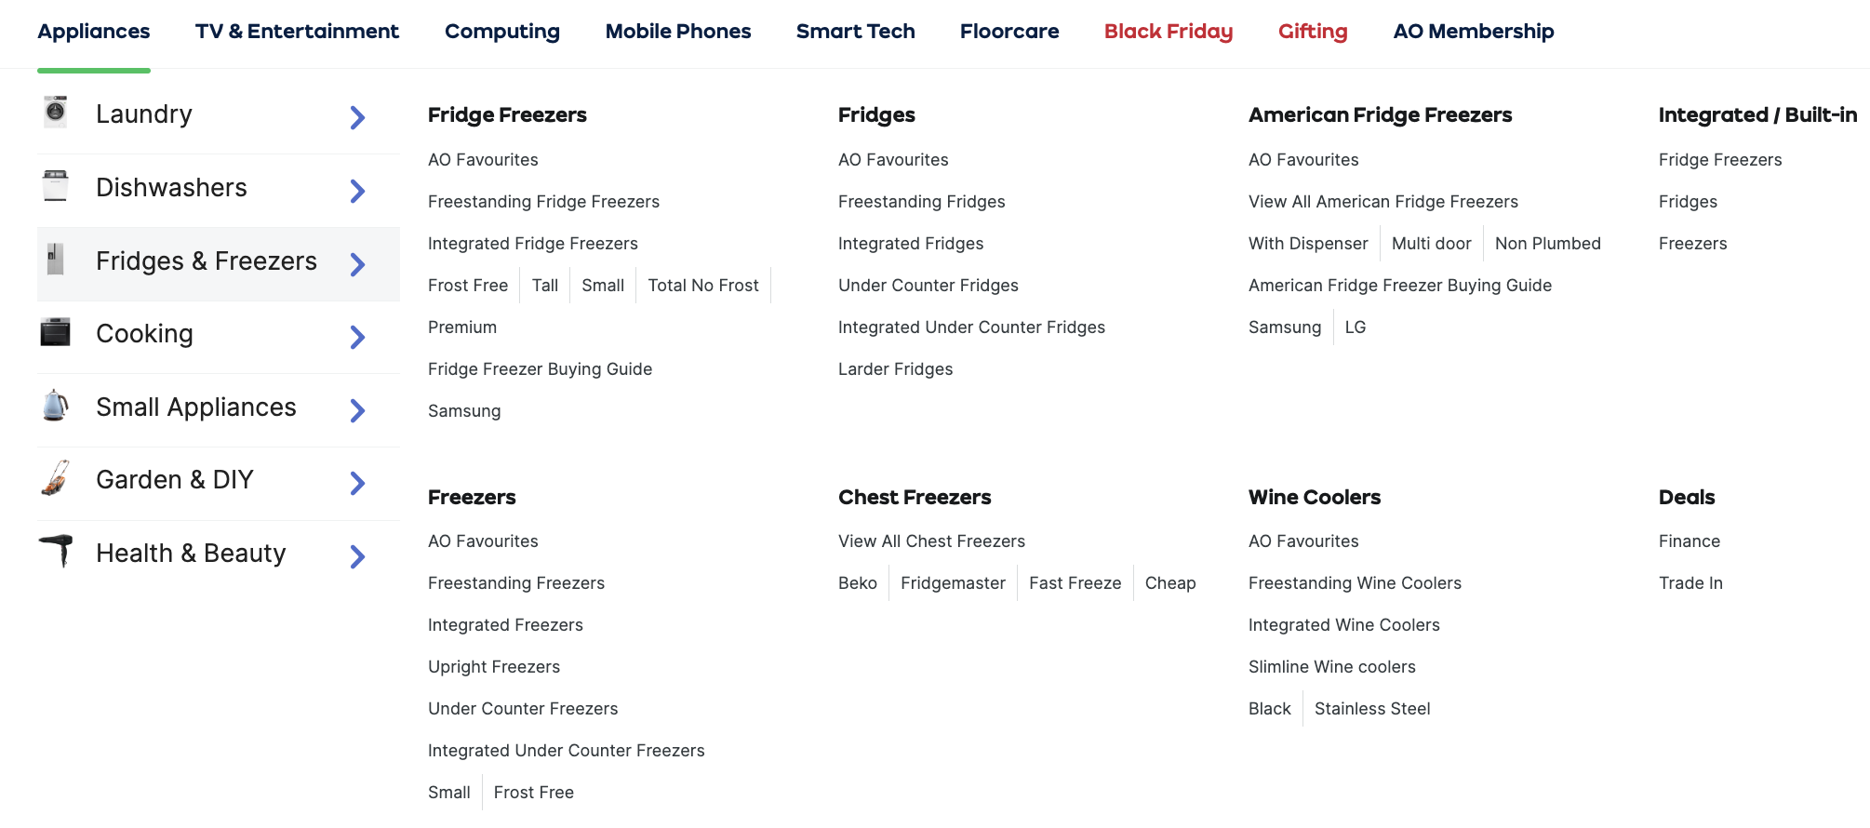

Figure 1 shows the subcategory of the fridges category on the AO website.

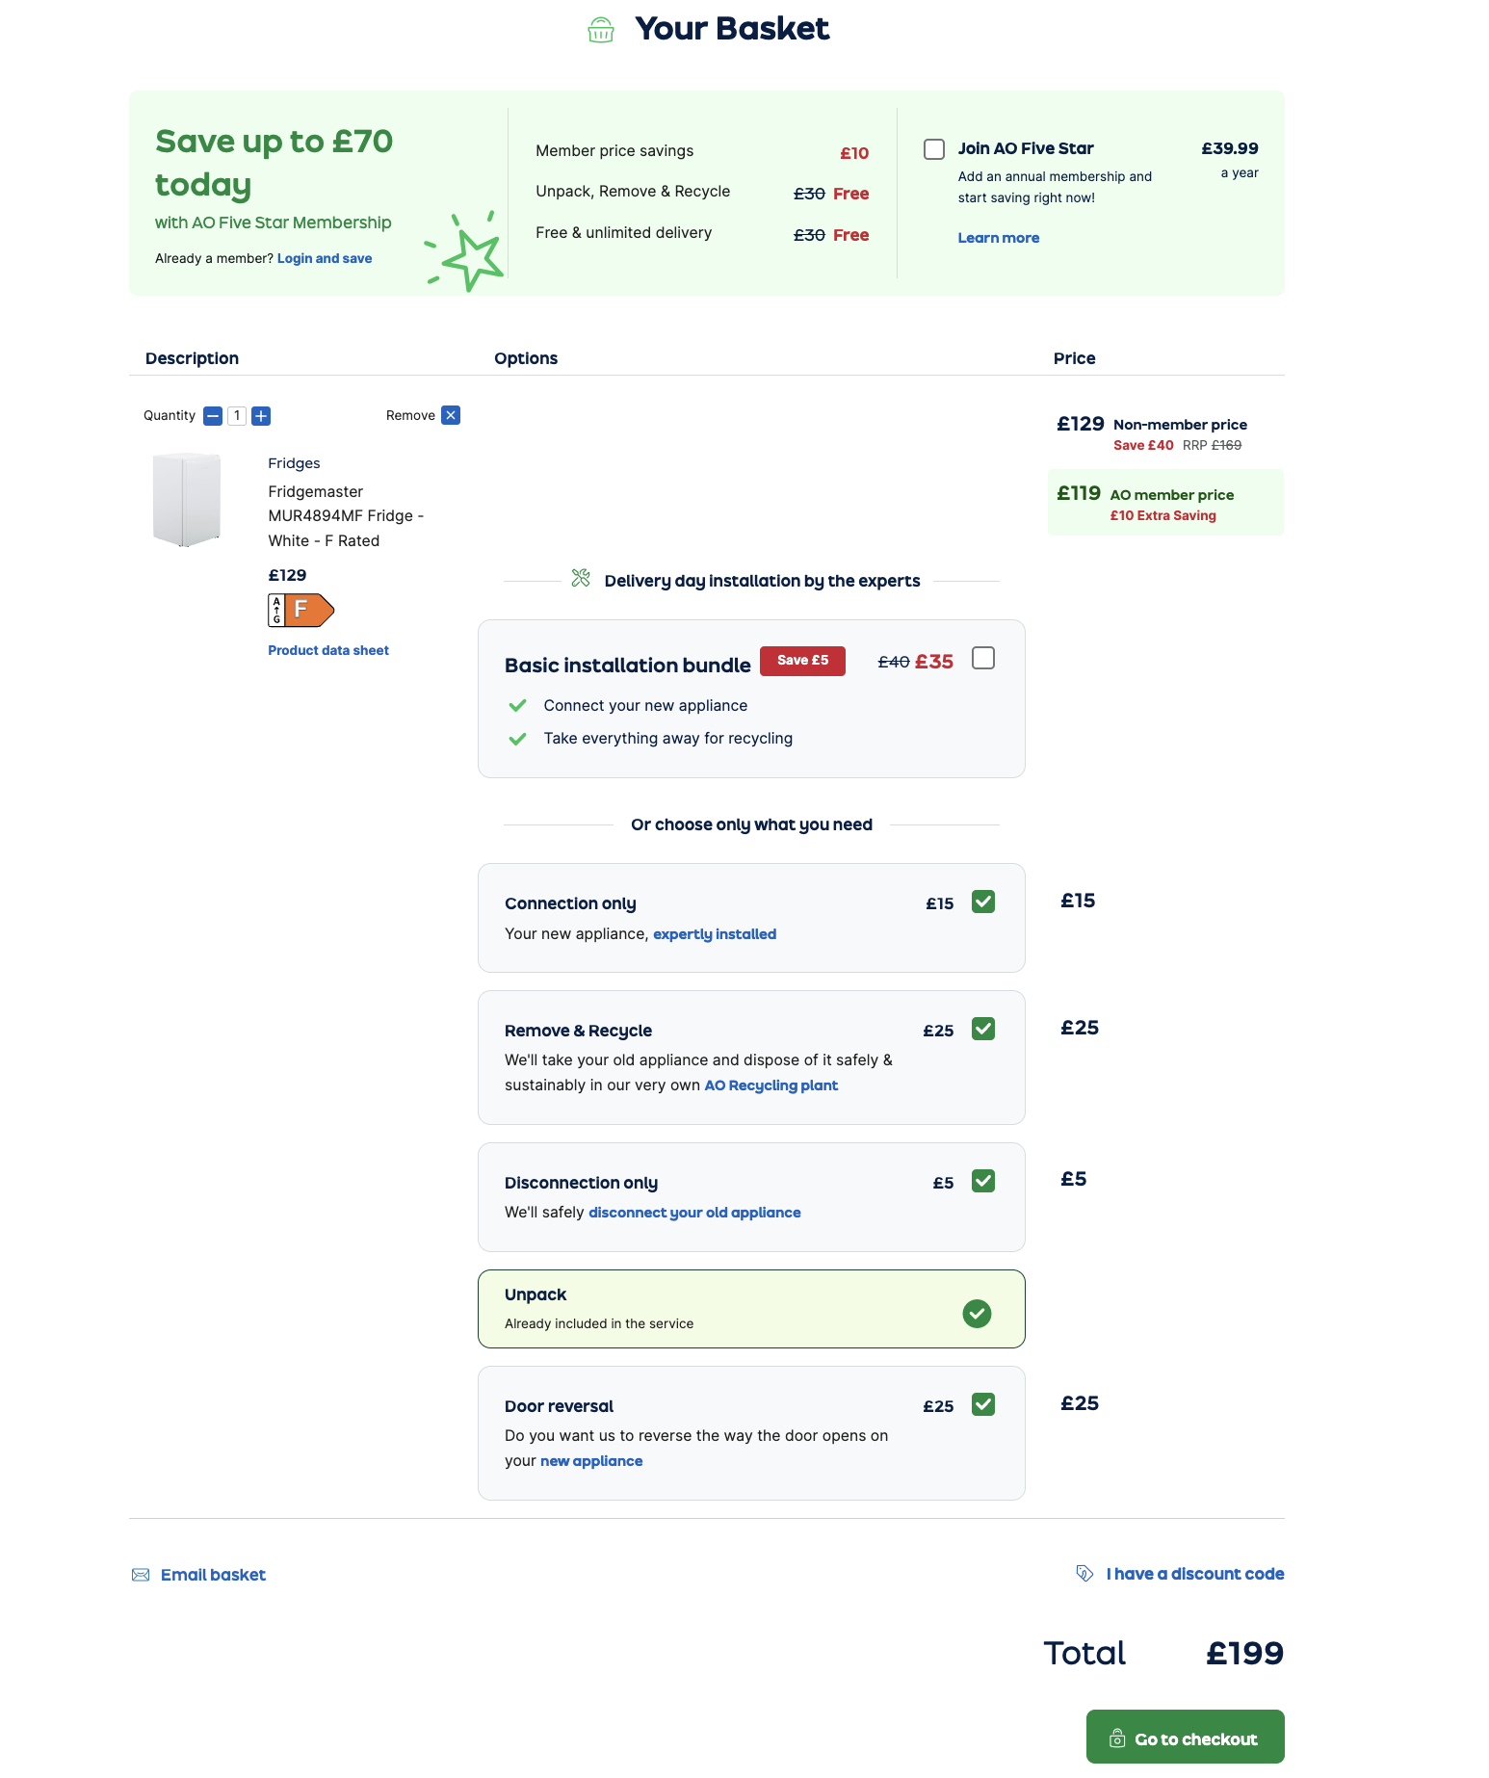

Figure 2 shows the “your basket” interface on the AO website.

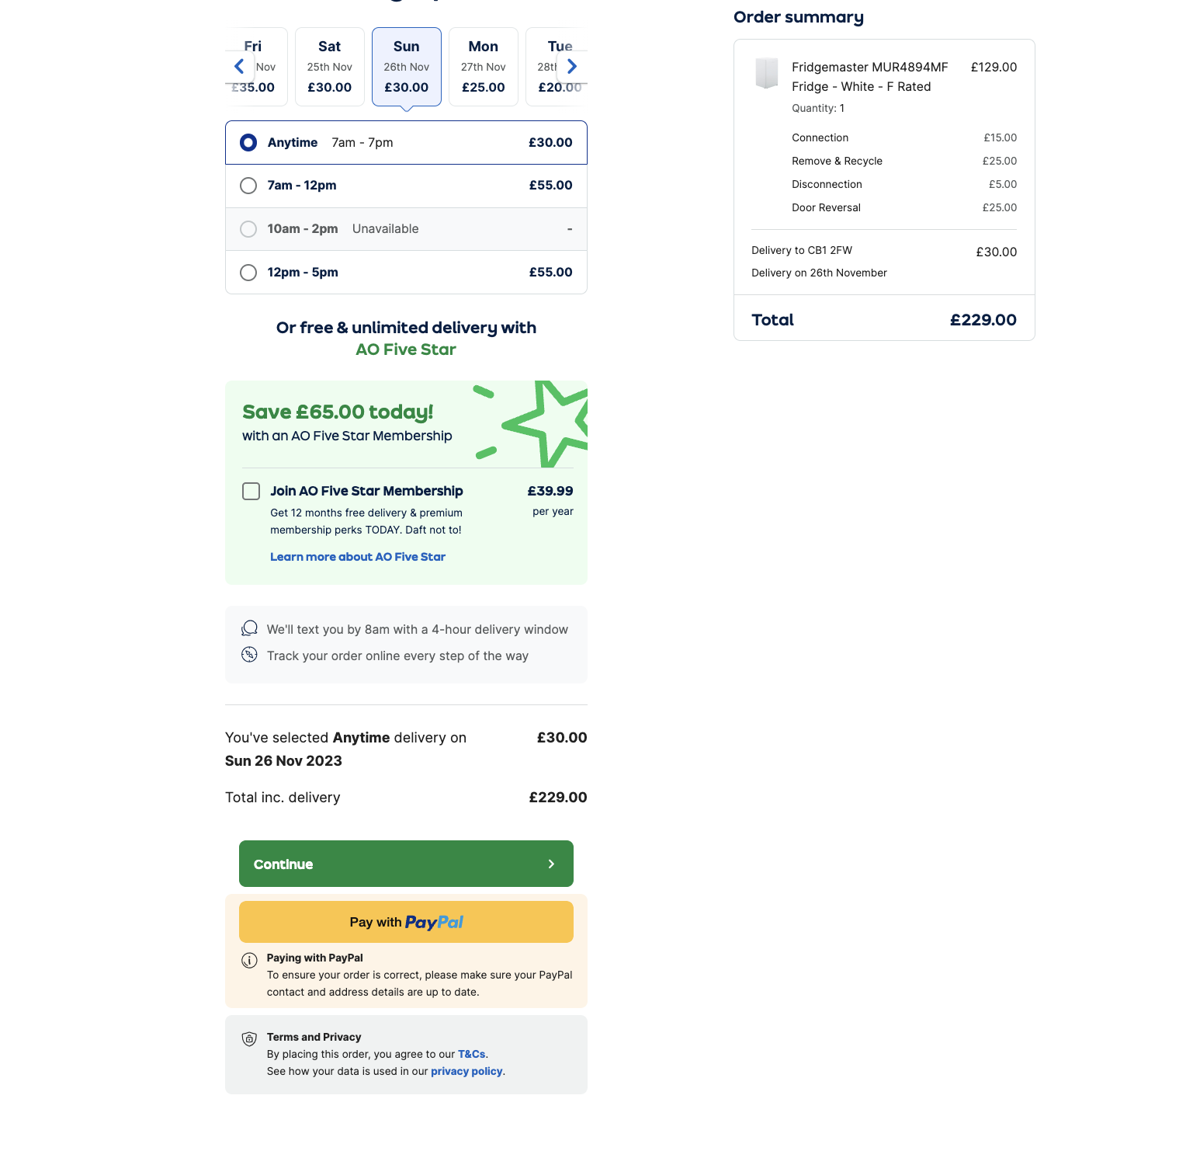

Figure 3 shows the ‘total price ‘after including the additional services and costs.

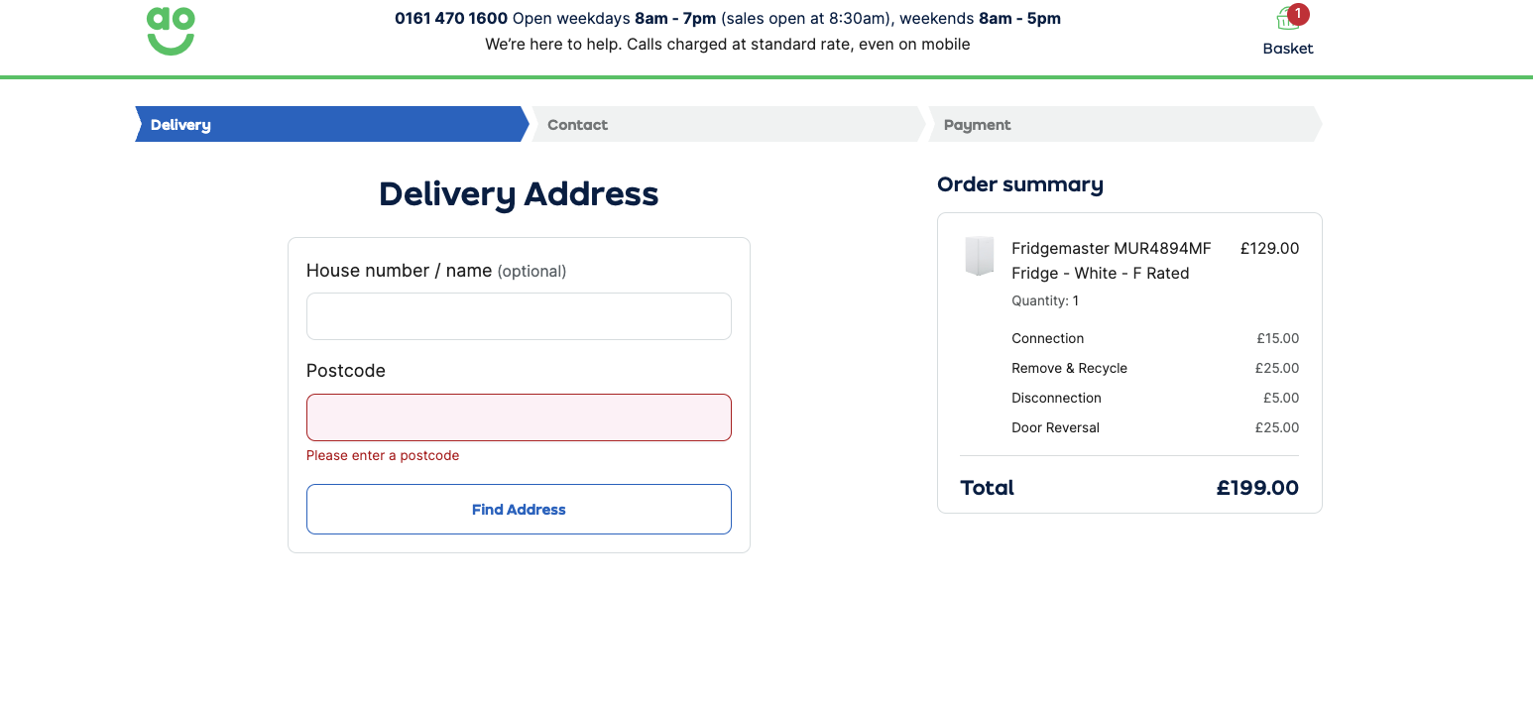

Figure 4 shows the delivery interface if there are no account details saved. A postcode is used to retrieve the address of the customer. If not found the user can manually add his address information. These will all be recorded as attributes.

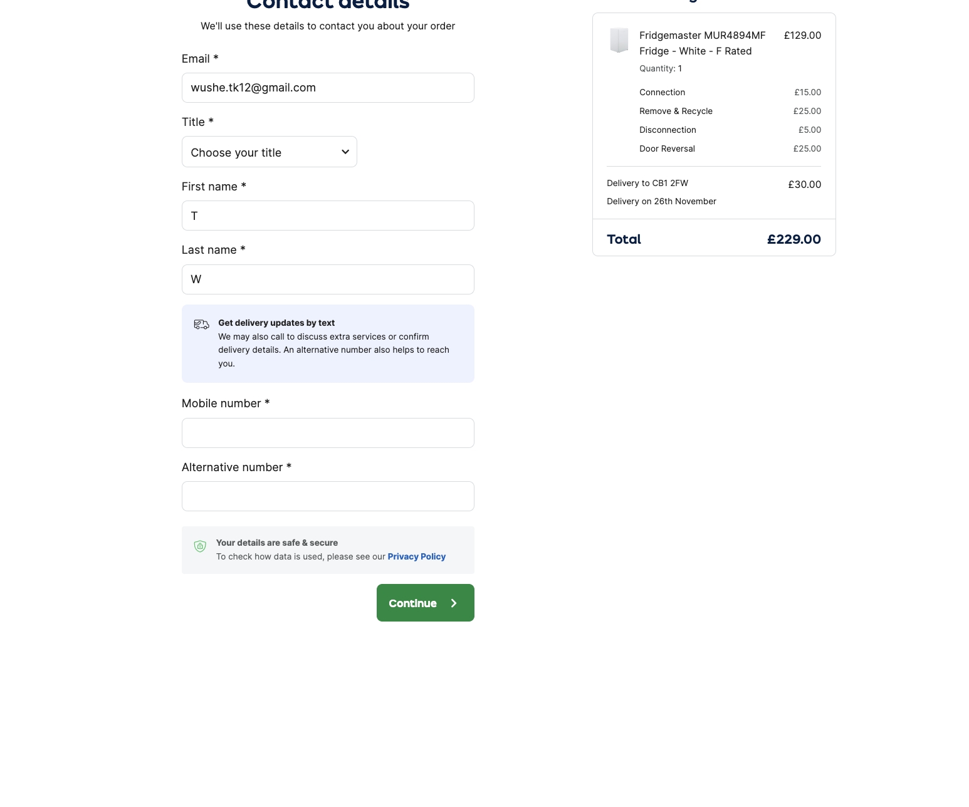

The fifth figure above is the interface where the customer must enter details to be able to complete the order. Please note that all the fields below are mandatory to complete the order as shown by the asterisk.

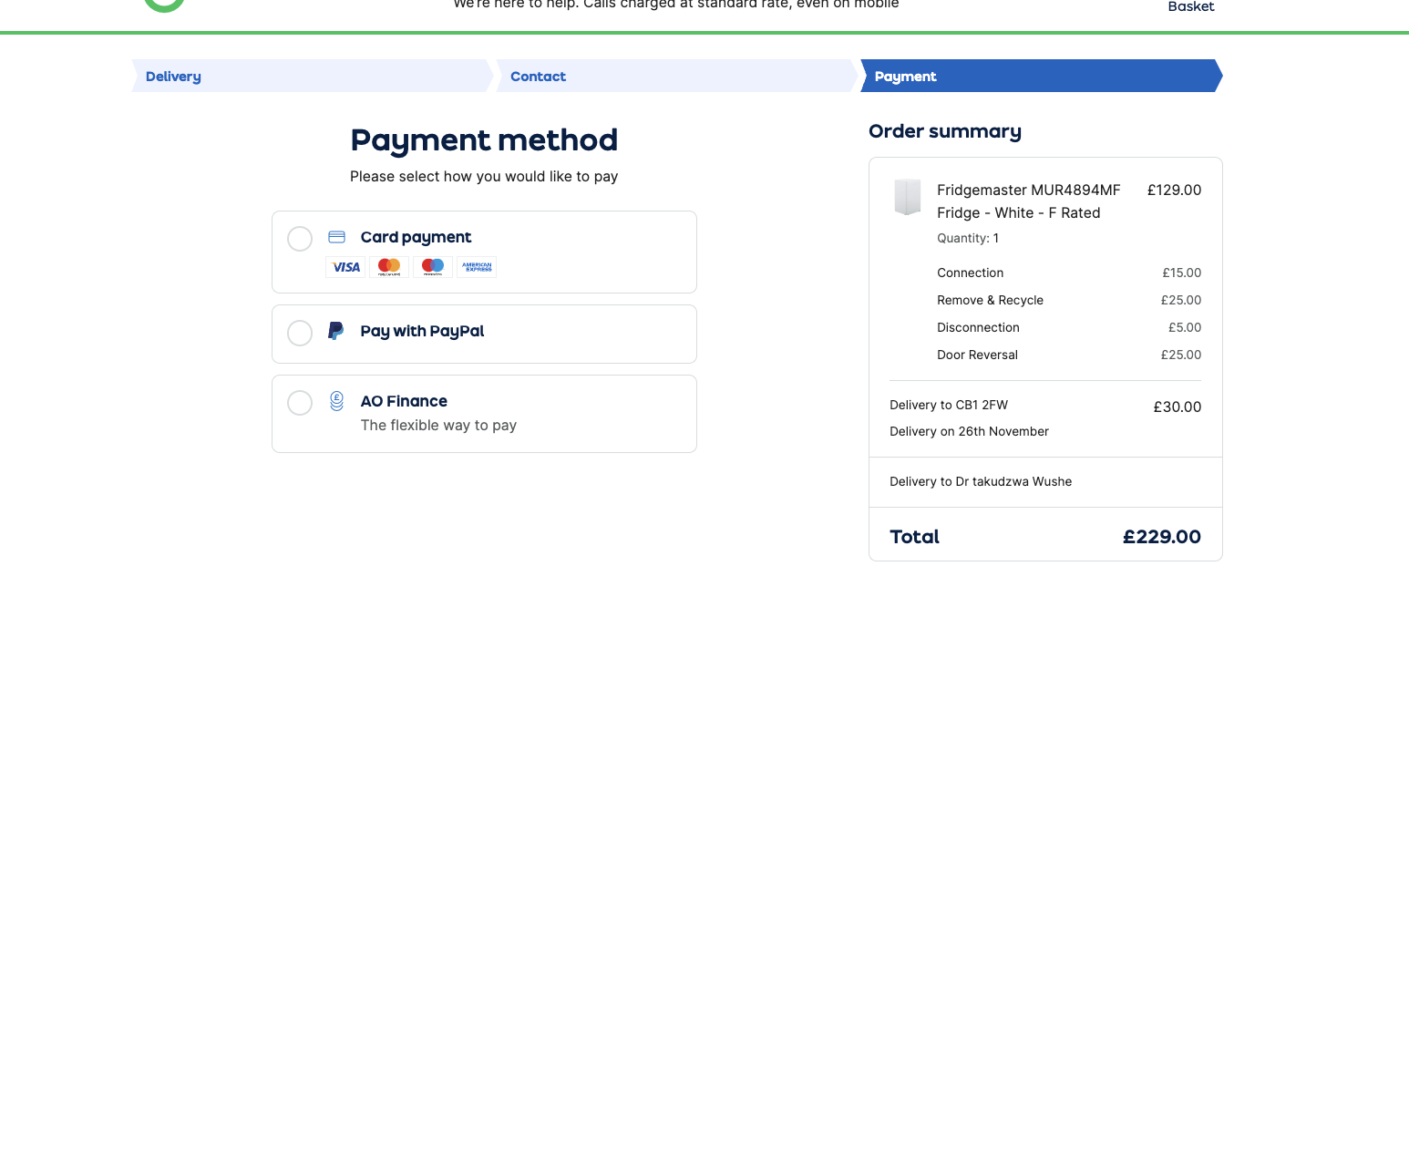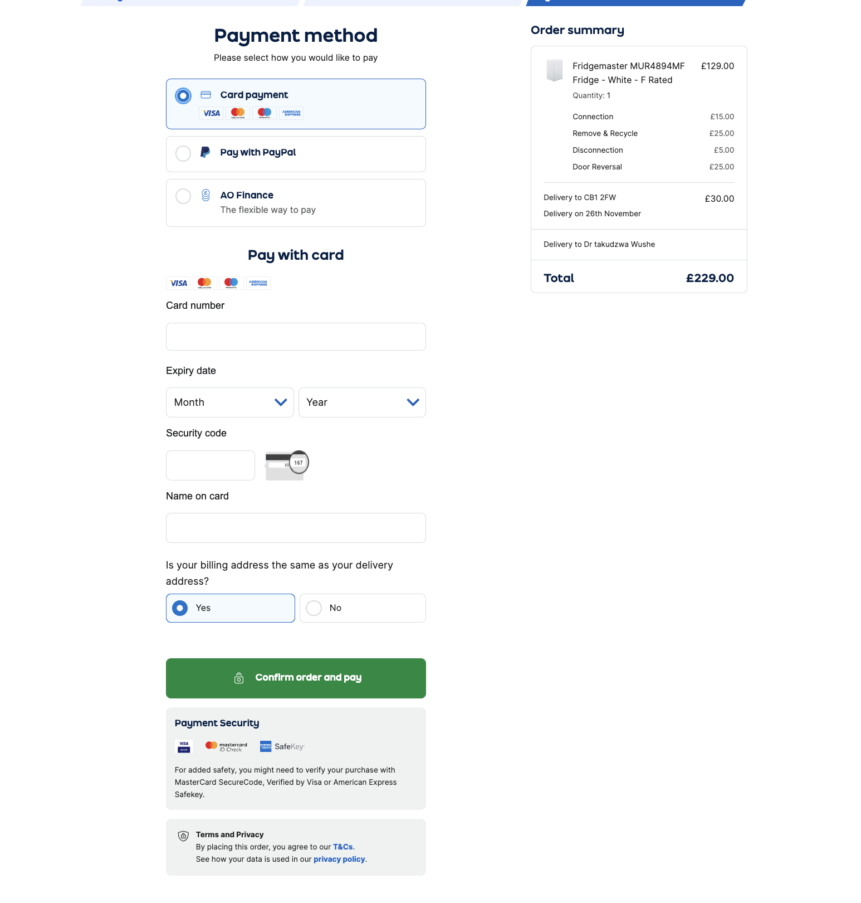

Figures 6 and 7 show the payment options available to the customer. Figure 7 shows a more in-depth view of the ‘pay with card’ option where the user enters several fields which have been considered whilst curating the table mentioned previously.

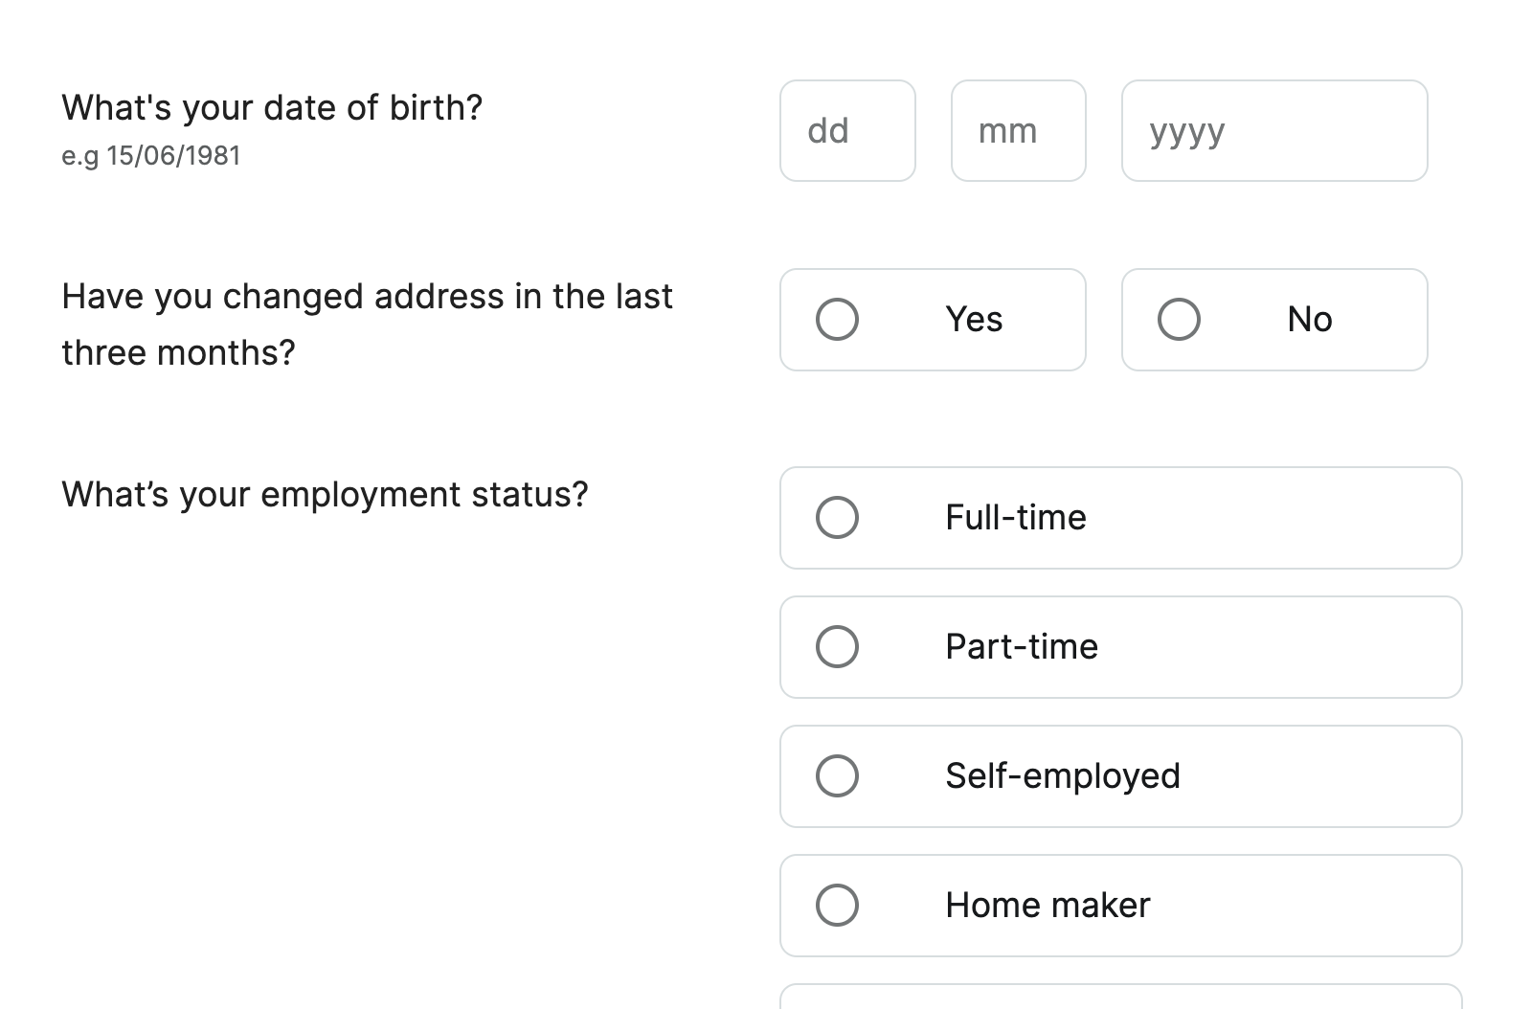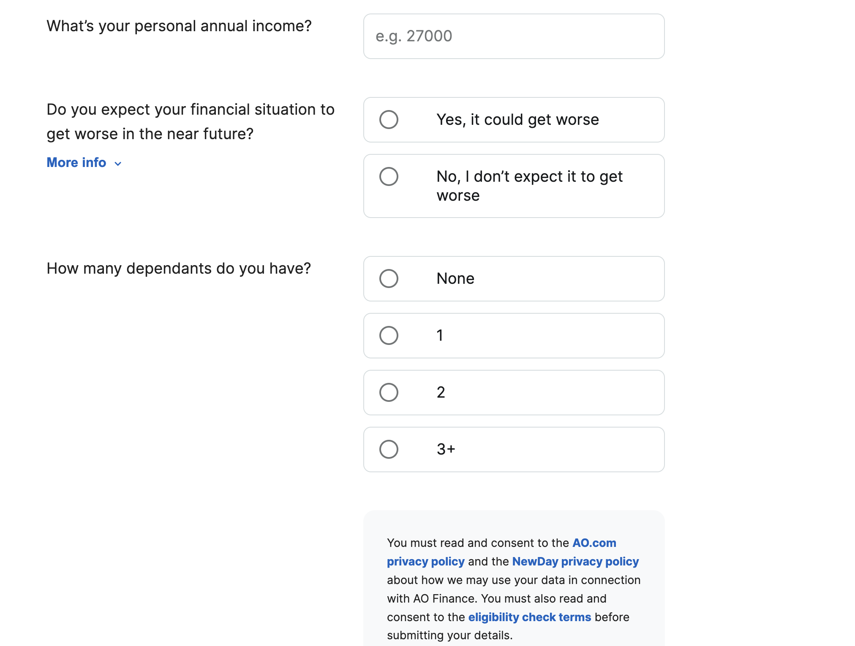

Figures 8 and 9 show the attributes entered if the customer has chosen the ‘Pay with AO finance ‘method. It is worth mentioning that all these fields have been considered when making Table 1 but have been omitted because the method is only available on this site.

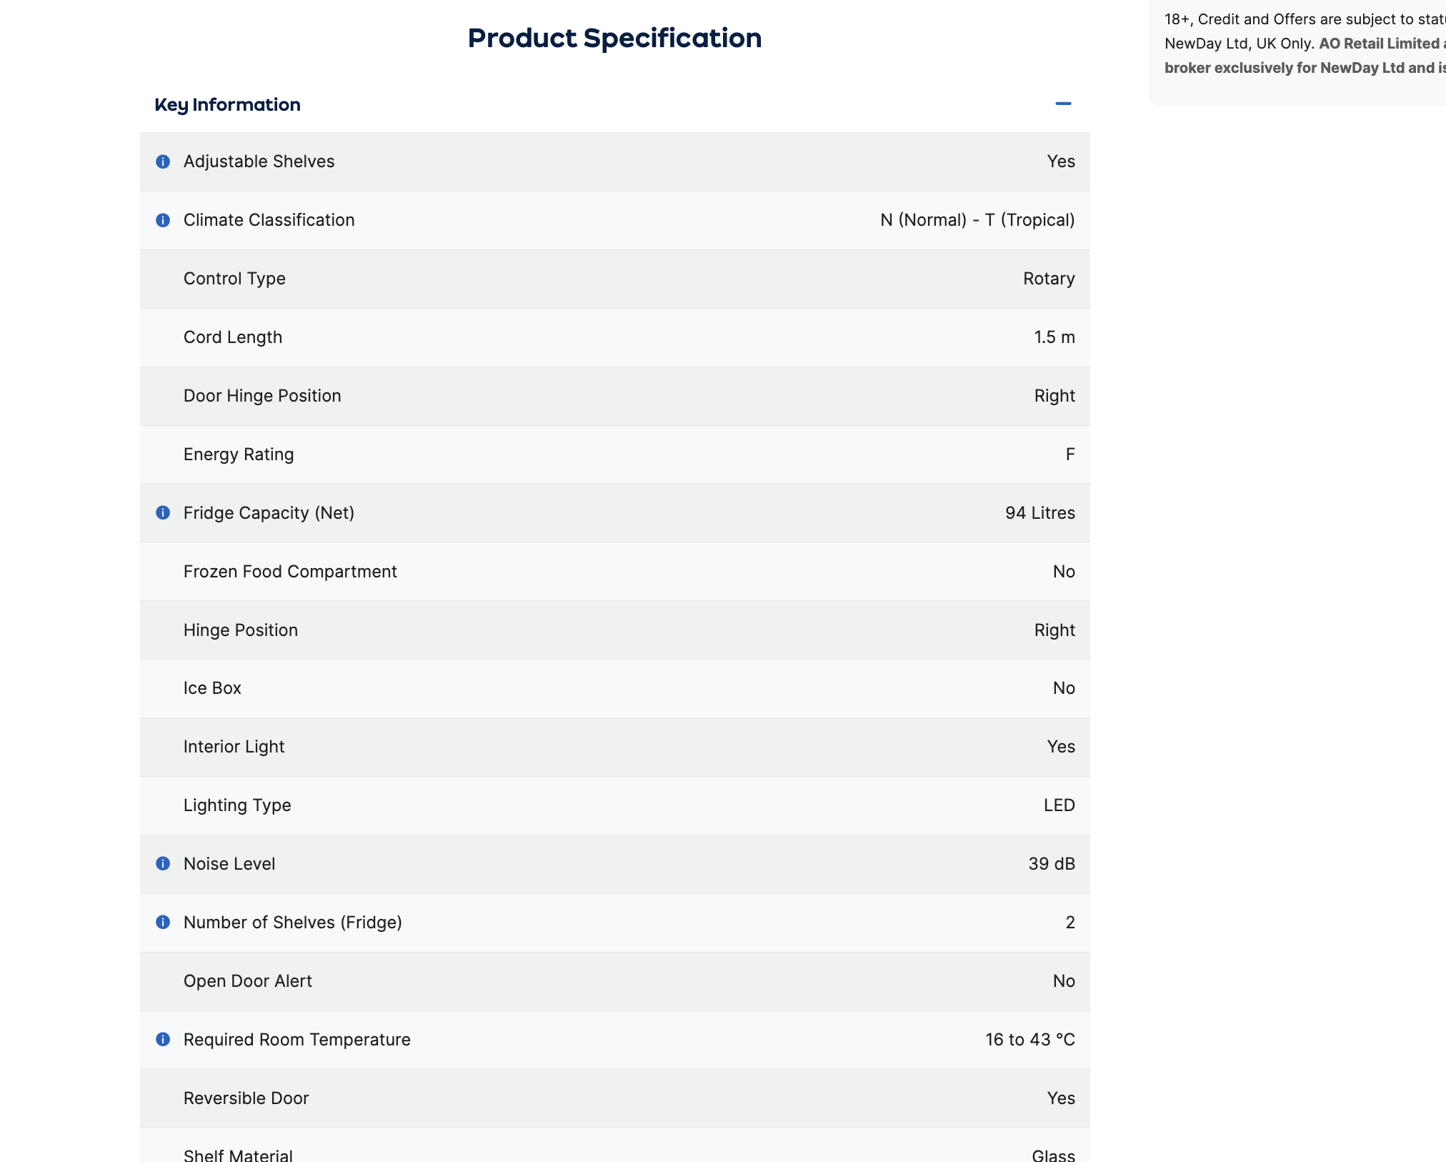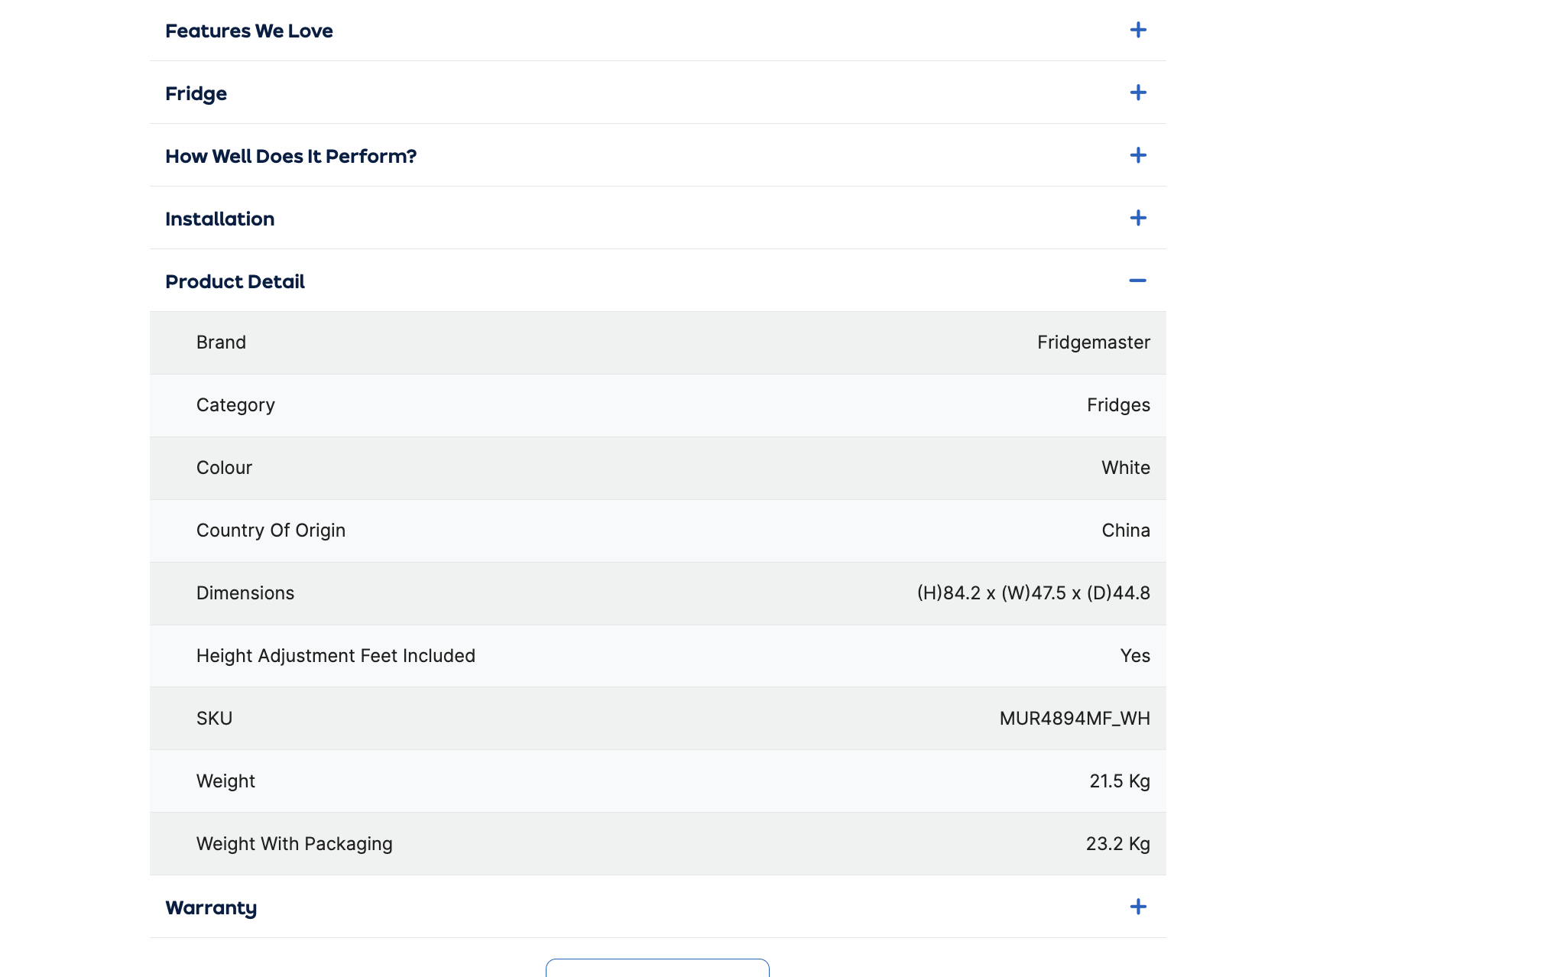

Figure 10 and 11: Screenshot shows the range of Fridge attributes that have been stored to be displayed to the customer. For simplicity’s sake, the attributes have been captured as screenshots and not included in the main table.

Overall, the analysis revealed that is site has been to be tailored to invite the user to add additional costs to their orders using radio buttons to easily select options like the ‘basic installation’.

### List of data fields from website 2

Table 2: List of data fields extracted from Appliances Direct website.

|  |  |  |  |
| --- | --- | --- | --- |
| Title | Order Number | Company Name | IKEA Business card number |
| First Name | Click and collect | Payment | Your Purchase Order Reference |
| Last Name | Products price | No Worries - Extend Your Warranty to 3 Years | Card Number |
| Birthdate | Delivery Type | Door Reversal of your new appliance | MM/YY |
| Email Address | Subtotal | If your appliance has an ice maker, is the water pipe easily accessible behind the fridge? | Security code |
| Password | Discount | Room of Choice Delivery & Removal of Packaging | I accept the terms and conditions |
| Phone Number | Total | Remove & Recycle Your Old Appliance | Product quantity |
| Check for TaskRabbit availability(need help with assembly) | Postcode | Go to checkout | Date purchased |
| Address | Delivery Price | Expert installation of your new Appliance | Grand total |
| I would like to receive news, tips and offers from IKEA. | Total | Is the new appliance the same size as your existing one - will it fit in the same space? | Street 1 |
| Via email | VAT | If your appliance has an ice maker, is the water pipe easily accessible behind the fridge? | Town or City |
| Via SMS | Where should we send your order (IM a business customer TICKBOX) |  | Street 2 (optional) |
| Via direct mail |  |  |  |
| Terms and conditions |  |  |  |

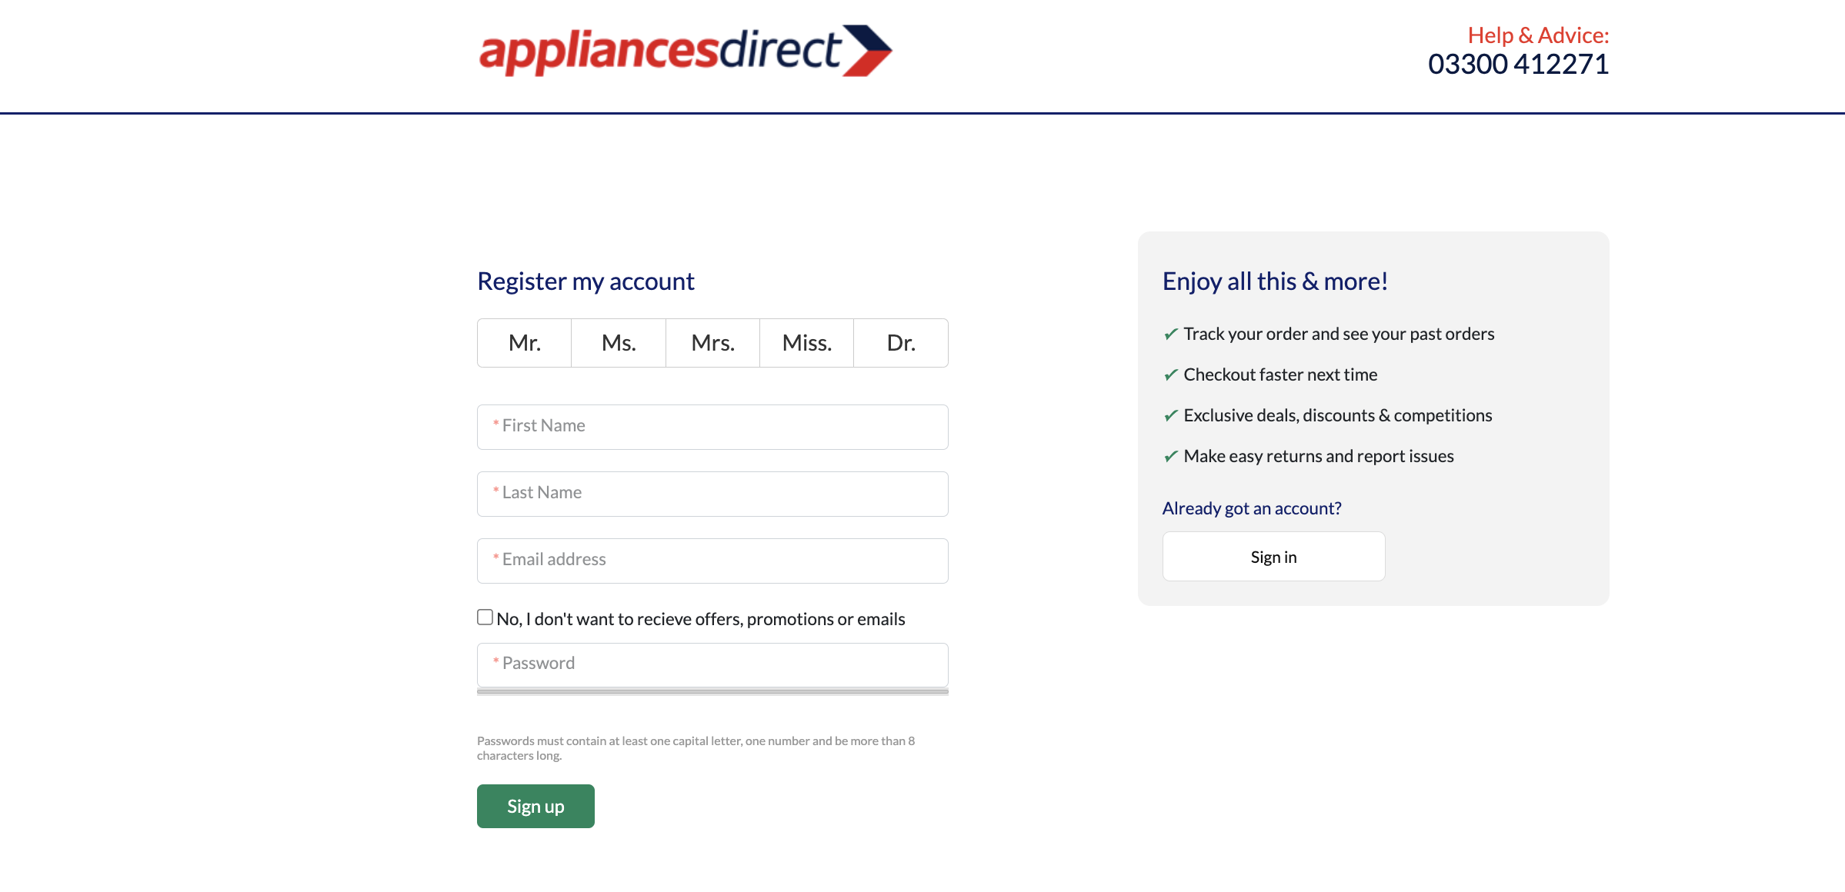

Figure 11 above show the ‘Register my account’ page which shows the attributes entered by the customer. The Title input has been made to be a radio box to reduce error from being inputted as well as the tickbox below ‘email address’. This information will be key implementing the database.

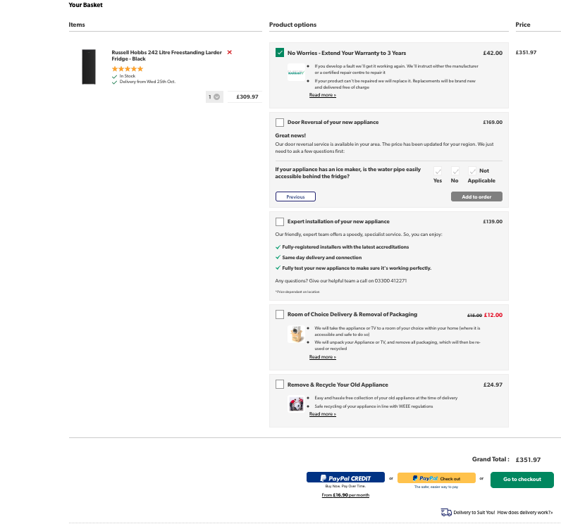

Figure 12: Screenshot o the ‘Your Basket’ page on Appliances Direct

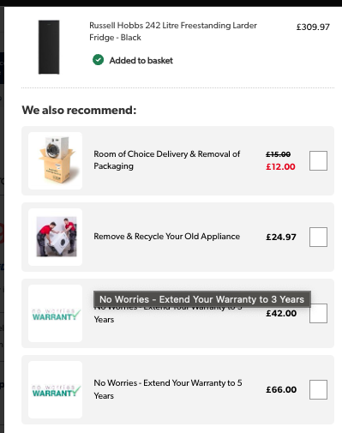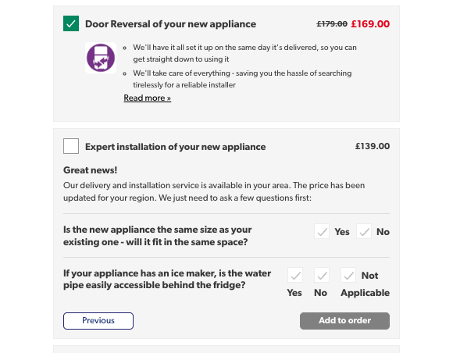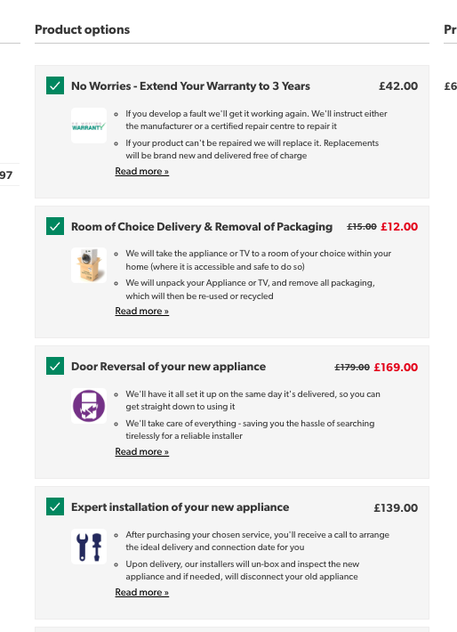

Figure 13(top left) 14(top right) and 15 (bottom left): shows the range of radio buttons and tick boxes available on your basket page on the Appliances Direct website.

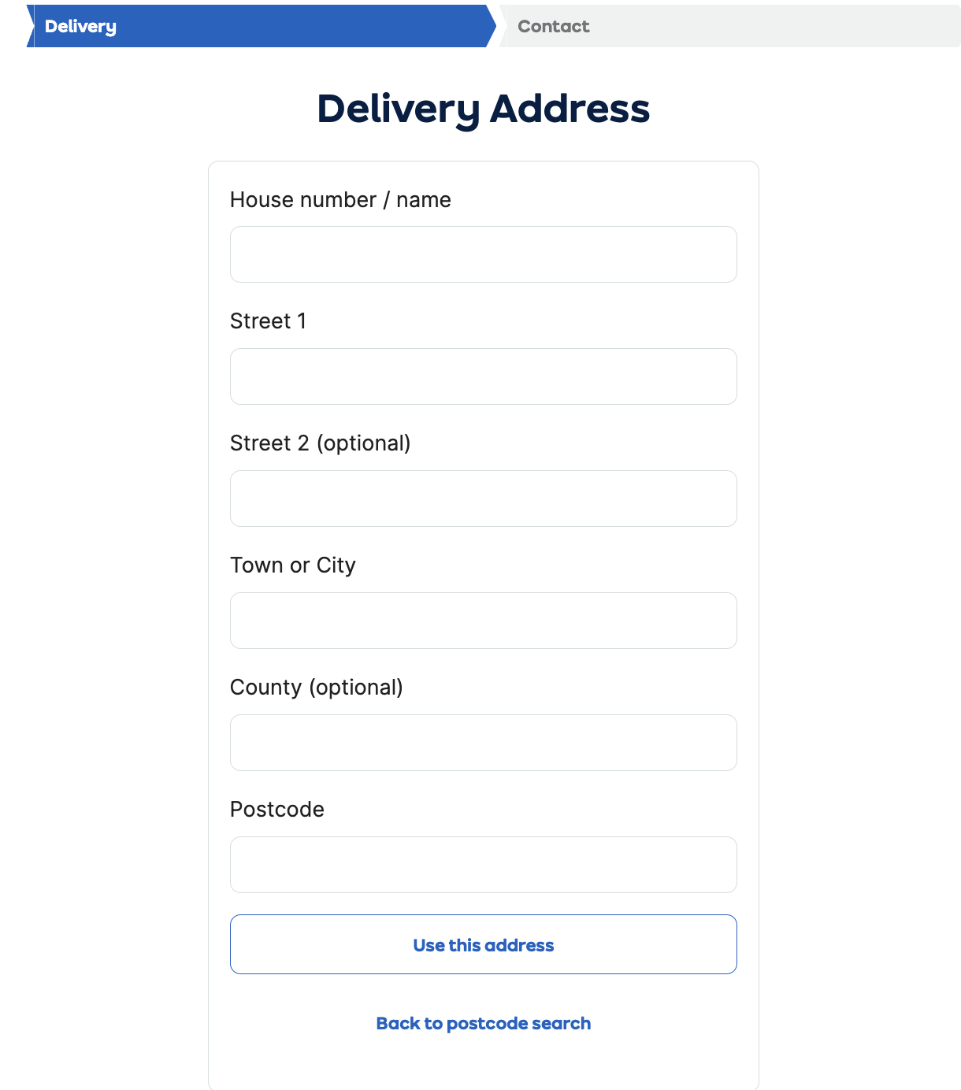

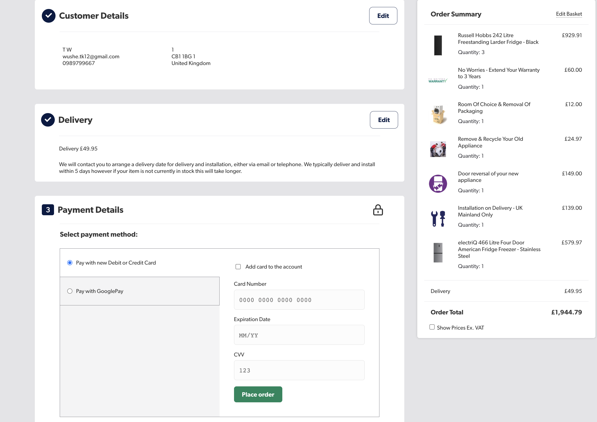

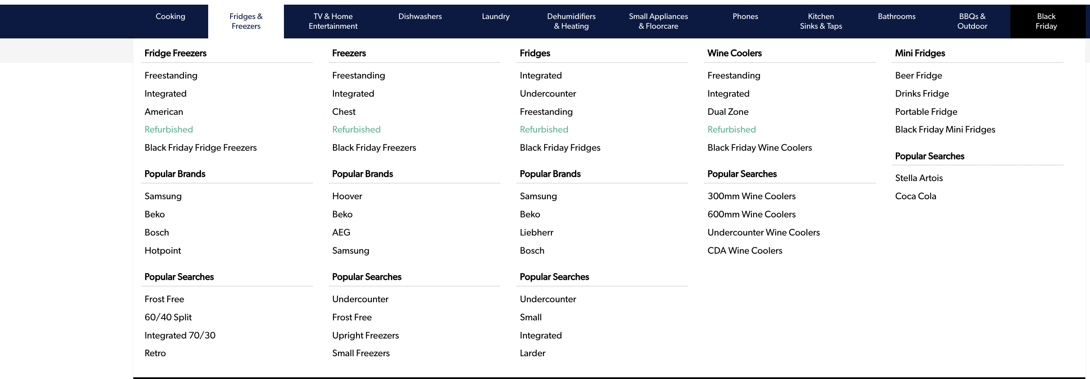

Figure 18: Screenshot of subcategories and categories of the Products Category on the Appliances Direct website

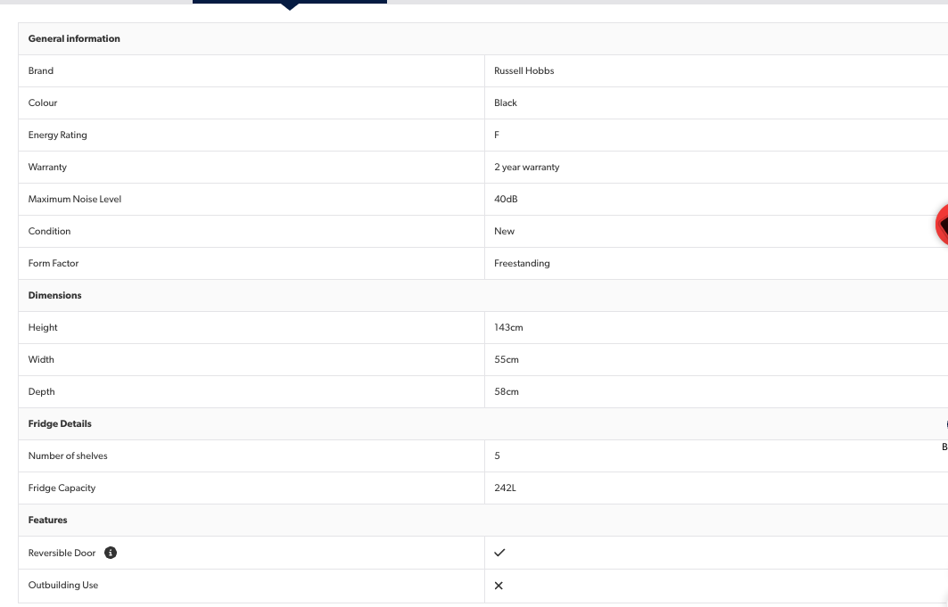

Figure 19: Attributes related the Fridges category on Appliances Direct website.

All in all , Appliance Direct design is structure shows a plethora of appliances with detailed product descriptions and numerous user options for the customer to choose from. This structure makes it very similar to the AO website when comparing the data fields between in the tables . The data fields are complex with a wide variety of attributes to cater to the diverse range of products and services offered.

### List of data fields from website 3

Table 3: Comprehensive List of Data Fields Extracted from IKEA's Website

The table below provides a detailed breakdown of the various data fields collected from the IKEA website taking into account customer information, product details, and transaction processes. It's a crucial element for understanding the database requirements specific to IKEA’s online appliance purchasing system.

| **Customer** | **Communication Preferences** | **Order Details** | **IKEA Business** | **Payment Information** | **Delivery and Services** |
| --- | --- | --- | --- | --- | --- |
| Title | I would like to receive news, tips, and offers from IKEA | Subtotal | IKEA Business card number | Card Number | Check for TaskRabbit availability |
| First Name | Via email | Have a Discount? | Legal Business Name | MM/YY | Click and collect |
| Last Name | Via SMS | Total | VAT Number | Security code | Where should we send your order (I'm a business customer TICKBOX) |
| Birthdate | Via direct mail | Postcode | Industry Segment | I accept the terms and conditions | Delivery Type |
| Email Address(username) |  | Delivery Price | Company Name | Cardholder’s Name |  |
| Password |  | VAT | Business Postcode | Billing Address |  |
| Phone Number |  | Product quantity | Business City | Redeem a gift or refund card |  |
|  |  | Products price | Business Address |  |  |
|  |  | Date purchased |  |  |  |
|  |  | Your Purchase Order Reference |  |  |  |
|  |  | Order Number |  |  |  |

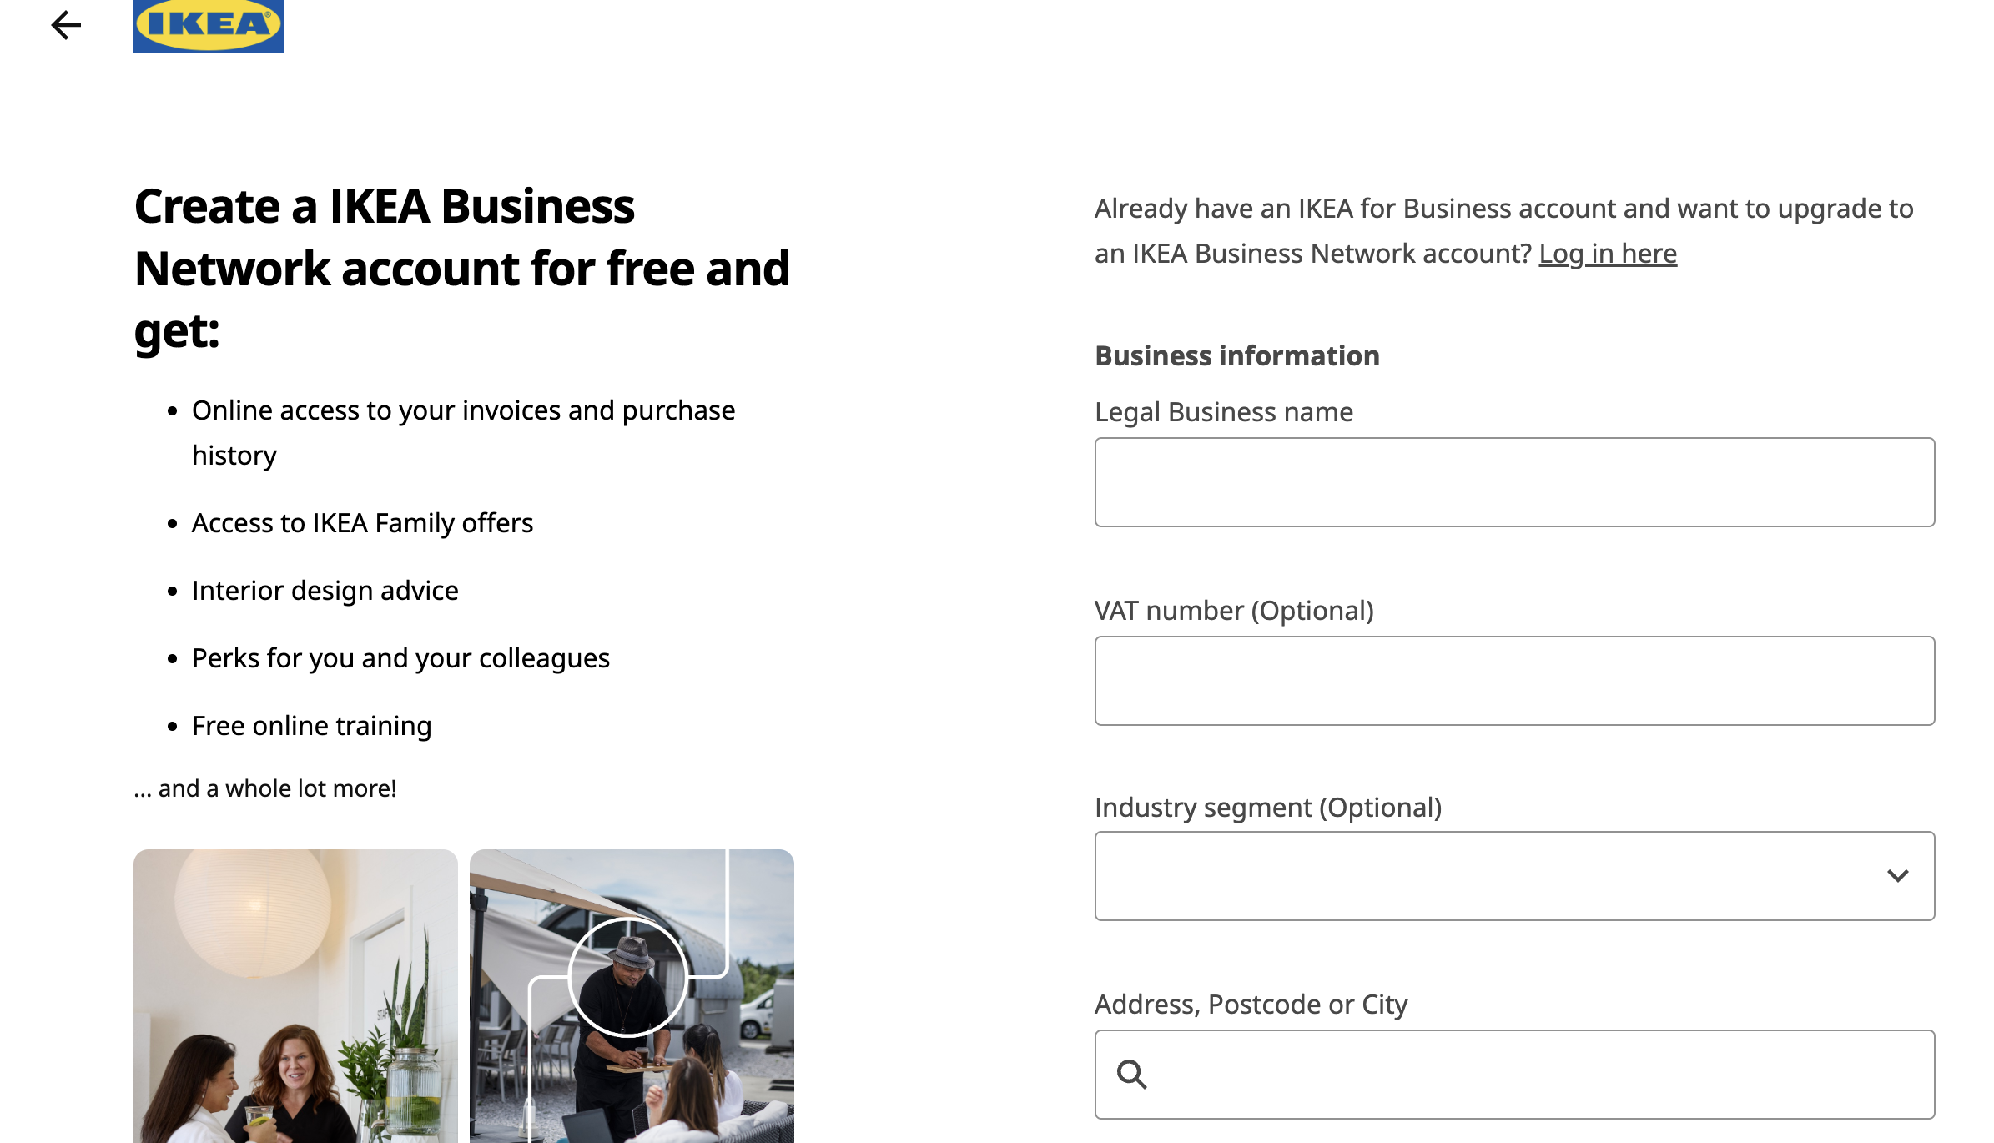

Figure 20: Screenshot Illustrating the Business registration process on IKEA Website."

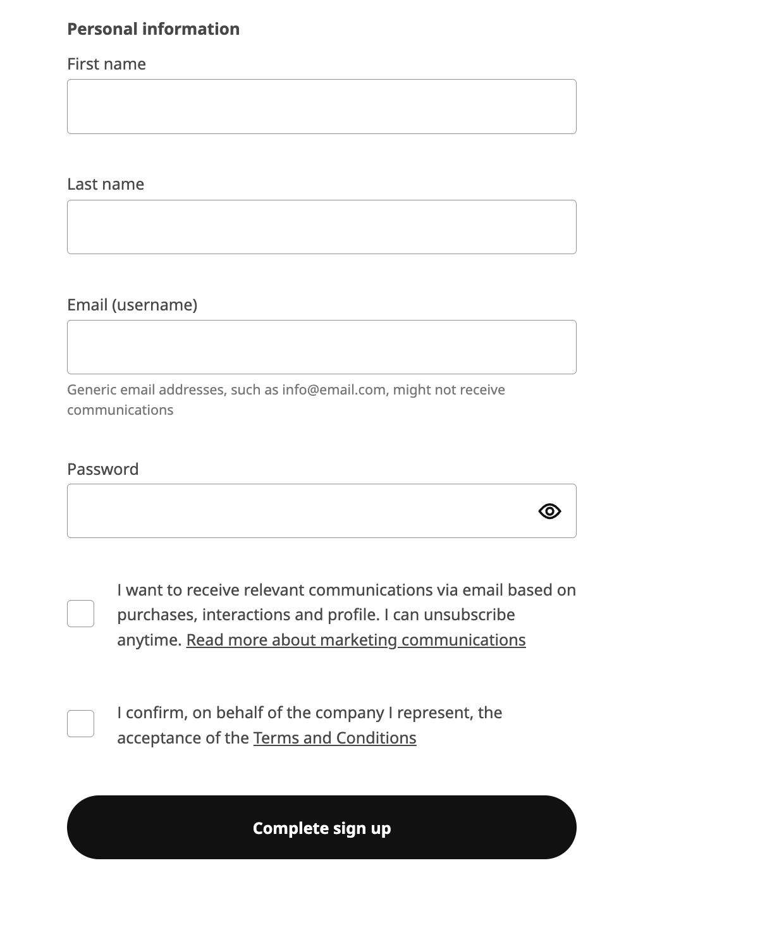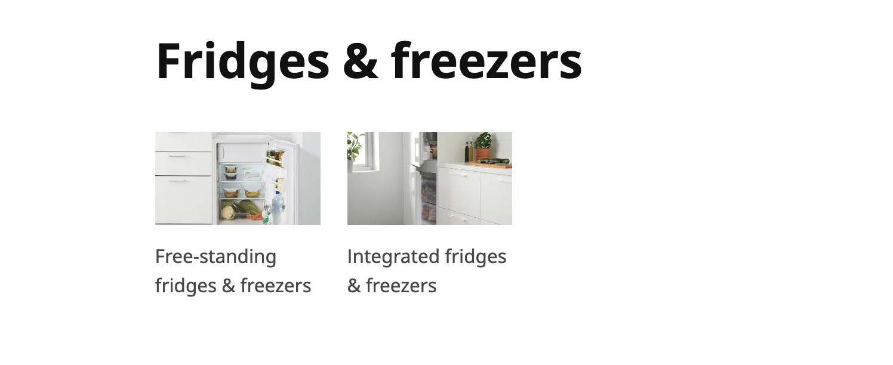

Figure 21(left): Screenshot Illustrating the customer registration process on IKEA Website.

Figure 22(above) : Screenshot Illustrating the Fridge sub categories on IKEA Website.

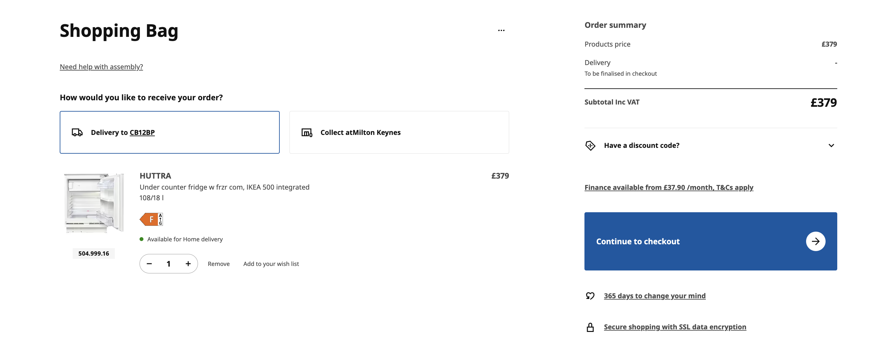



Figure 23(above) : A picture showing the ‘shopping bag’ interface on IKEA Website."

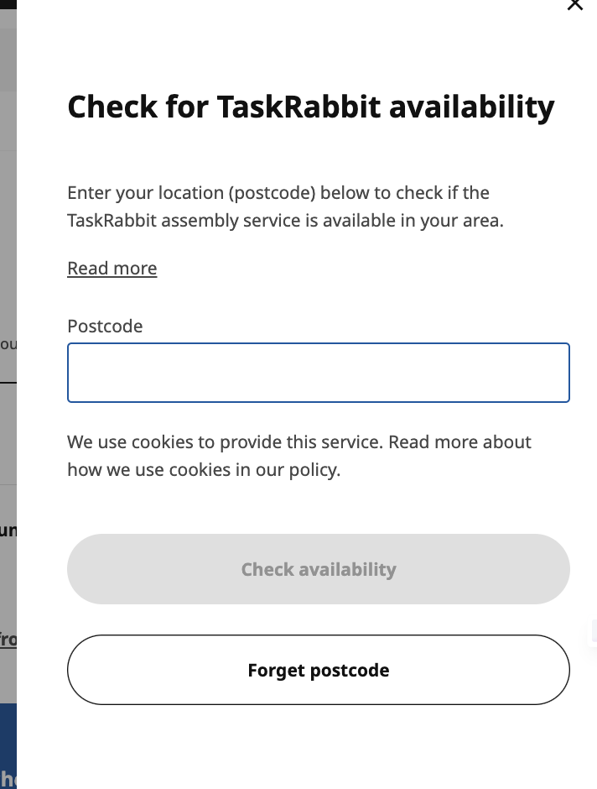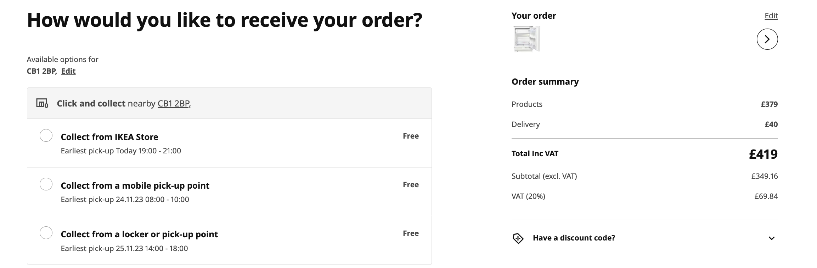



Figure 24(left) : Screenshot showing the functionality of the TaskRabbit checker on IKEA website. It is a special service provided by IKEA

Figure 24 above shows the Options offered to receive order customer categories on the IKEA Website.

Figure 25 below shows additional delivery methods offered to customer on the website

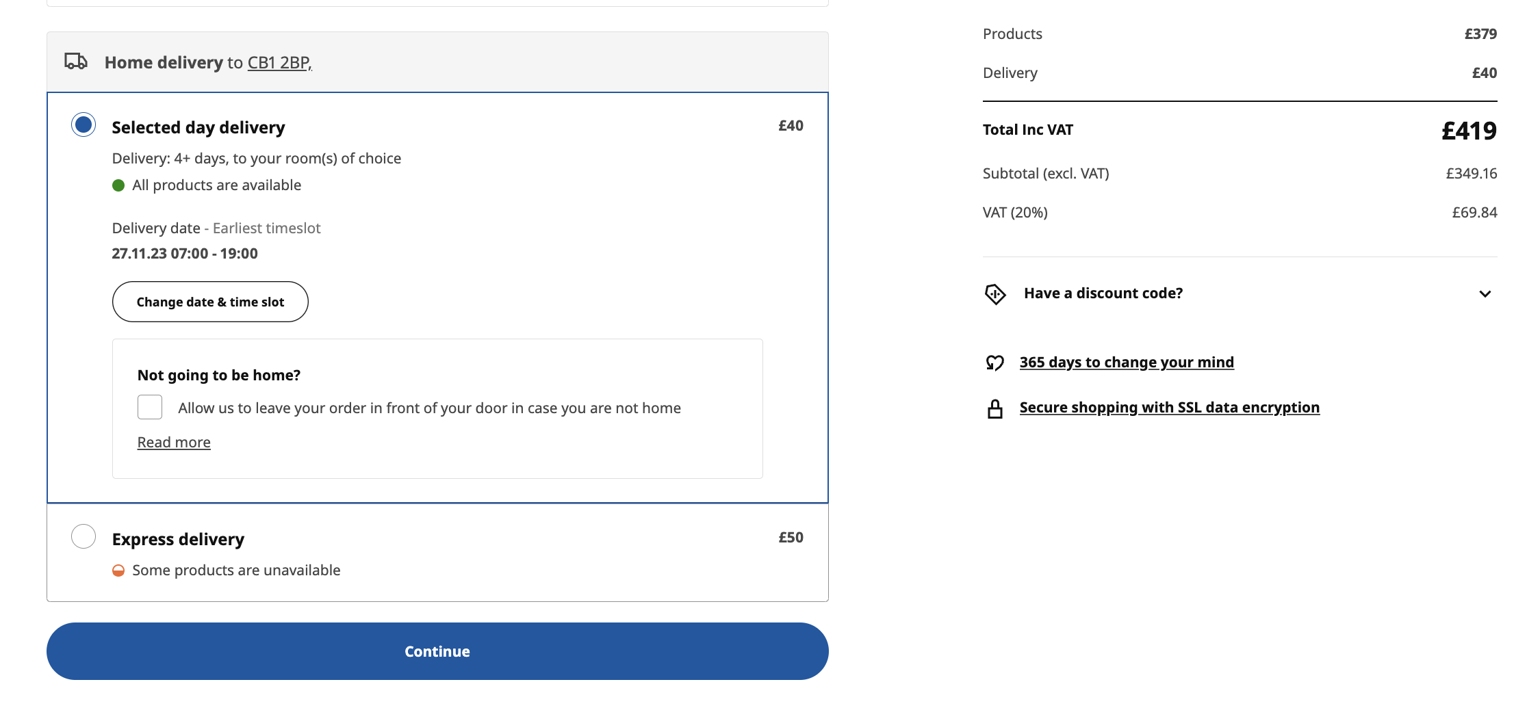

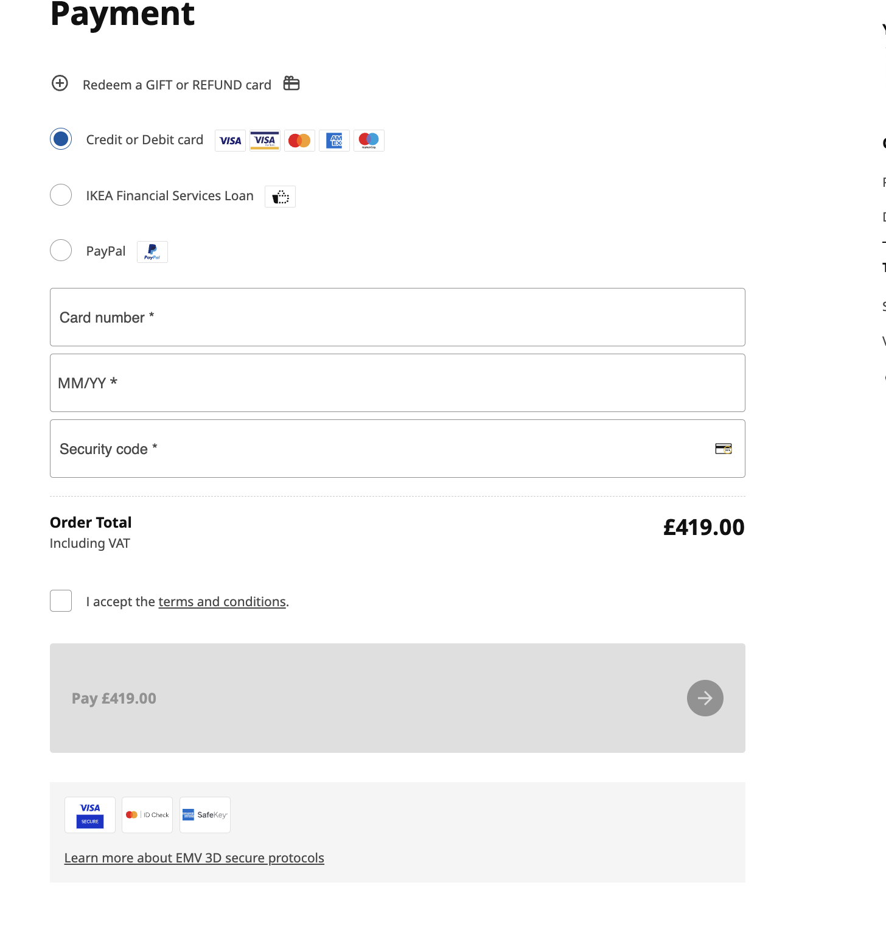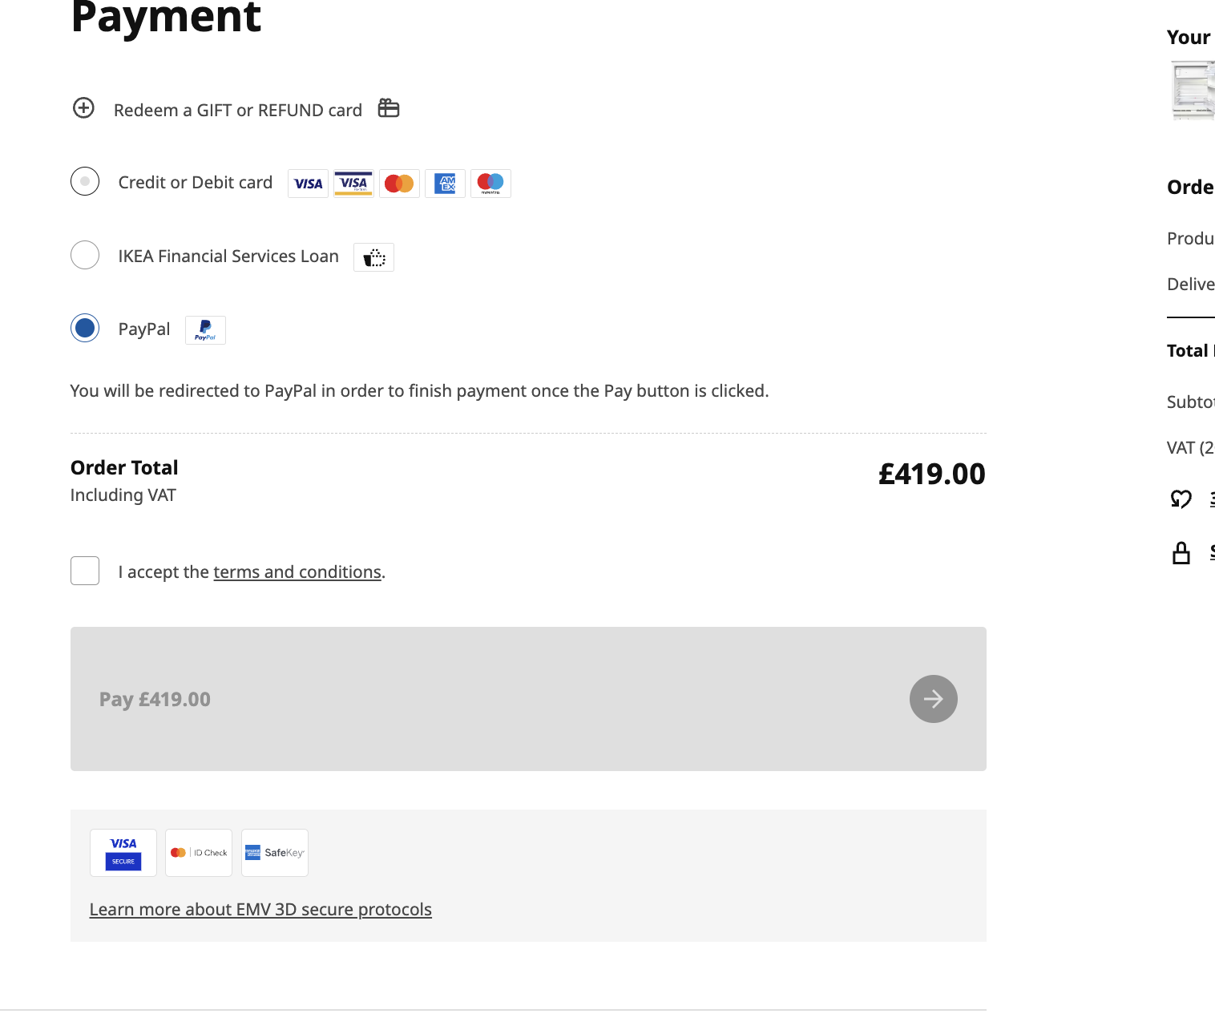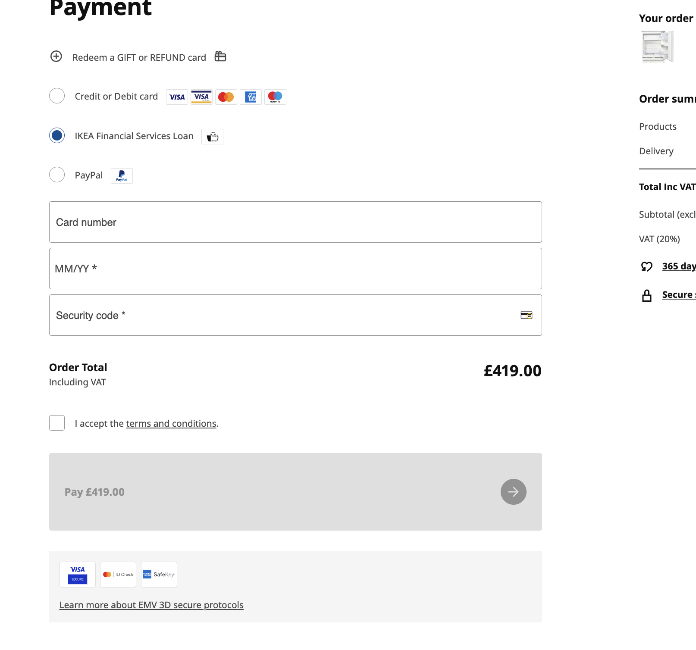

The screenshots on this page; (Figure26 -28) shows all the possible input fields required to process a payment on the IKEA website.

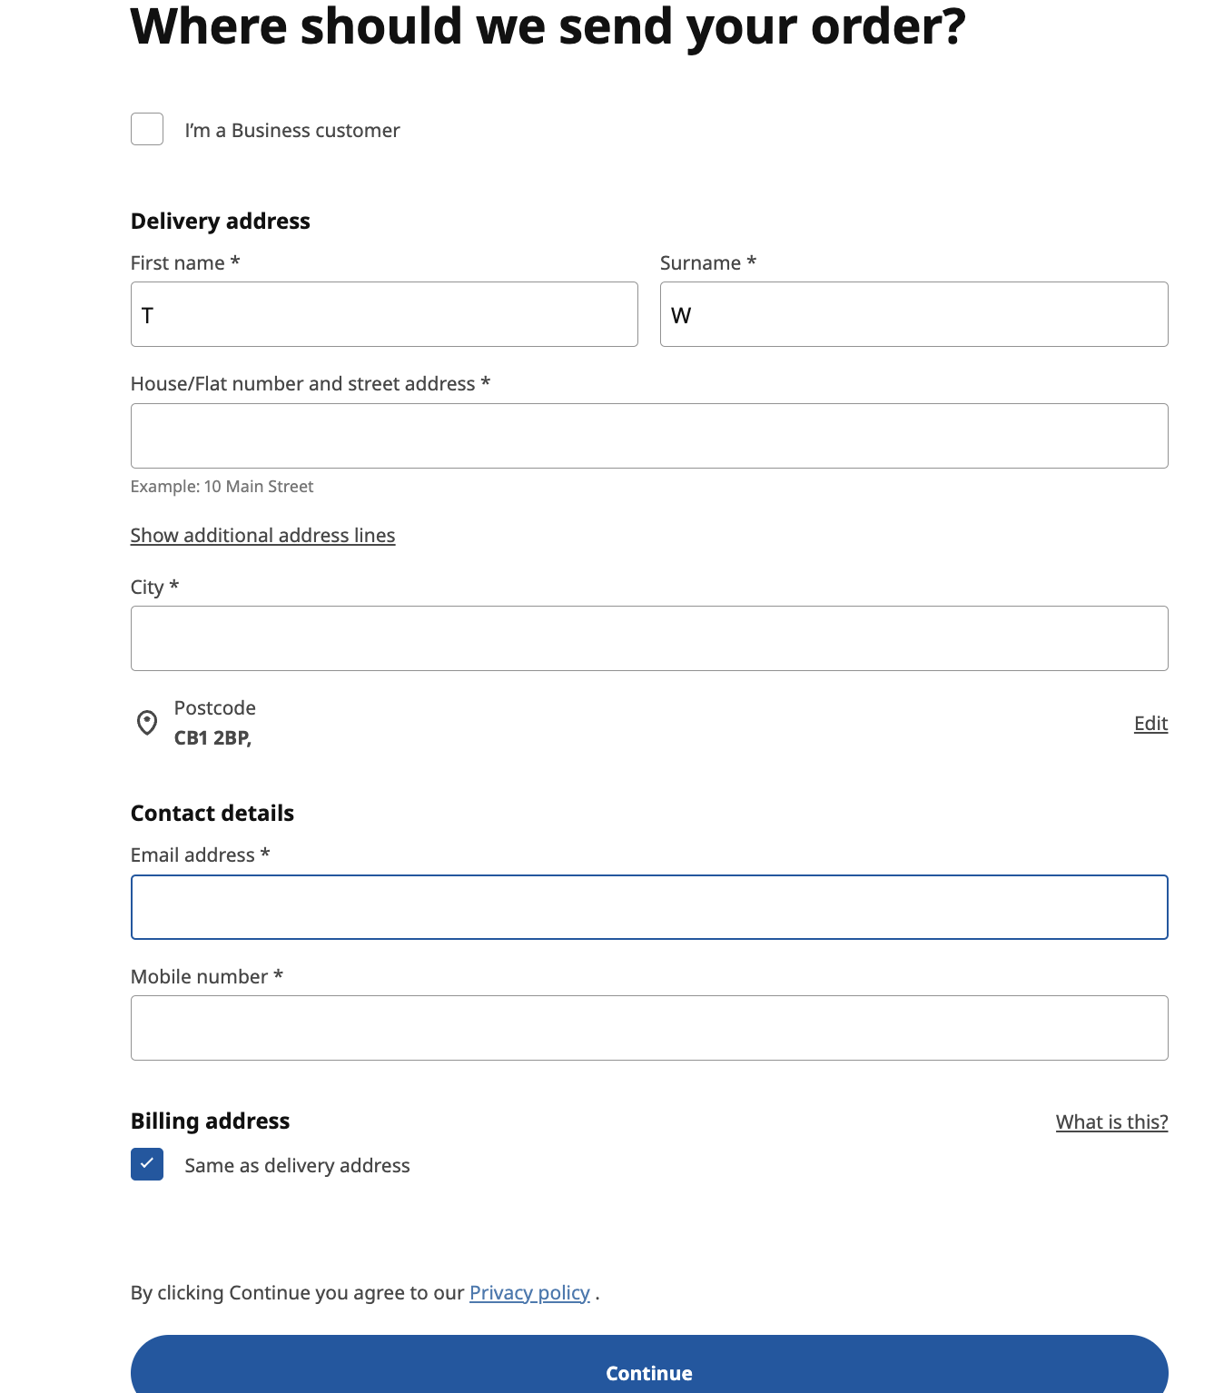



Figure 29 above shows the delivery address input fields the customer needs to fill to complete the order

In conclusion ,It is worth noting that the site mainly focuses on furniture, with a lesser emphasis on appliances.All in all, The data attributes here are more straightforward, with a limited range of product options and features, in contrast to the offers on the other 2 sites that are more focused on appliances. IKEA's approach emphasizes a more seamless online shopping experience, mirroring their focus on furniture and home accessories rather than a broad spectrum of specialized appliances. Consequently, the variety in fridge categories are narrower, aligning with IKEA's core business in home furnishing. Additionally, IKEA focuses on providing an exceptional in-store experience, complemented by an efficient online presence through its website. These strategies evidently show that IKEA's established brand identity and customer loyalty allow it to employ a more basic and less aggressive marketing approach compared to AO and Appliances Direct.

.

## 1.3 Finalised List

Table 4 shows the combined list of attributes from carefully analysing the 3 websites. Please note that some attributes have been generalised for functionality purposes. In addition, some attributes have been removed from the original lists and additional attributes have been included to improve the implementation of this database.

|  |  |  |  |
| --- | --- | --- | --- |
| Email | Price | Order_Status |  |
| User_id | Brand | Total_Price | Tax_amount |
| Password | Model | Payment_id | Additional_Service |
| First Name | Stock_level | Payment_method | Warranty |
| Last Name | Order_date | Credit_card_number | Tracking_Number |
| Address | Order_id | Expiration_date | Discount_code |
| Phone Number | Fridge_id | Billing_address | Discount_id |
| Product Name | Quantity | Shipping_id | Usage_limit |
| Description | name | Parent_category_id | Usage_counter |
| Category_id | Registration_date | Product_availabillity | discount_percentage |
| Order_item_id | Delivery_id | Delivery_Status | Address_city |
|  |  | Address_county | Address_country |

When creating this table, the idea was to create a field list that will only specialise in the stock taking, purchases made, and orders made for fridges. The author decided to make this decision as the overall theme from the requirements gathering was only related to Fridge purchases.

The proposed system that is to be built will be for a simplified international online commerce that distributes solely Fridges but has a vast range to choose from. With this knowledge, attributes like ‘IKEA business number’ and all the fields from the IKEA business entity have been rejected.

The target market is for individuals to conveniently purchase fridges that come with a plethora of additional services, warranty and a range of delivery methods.

The attributes added in this table have been added to facilitate future queries to be made to reward the customers. ‘Registration_date’ has been added with the idea of a data administrator later possibly sending automated emails with discount codes to the customers as a token of their loyalty. This in turn entices the customer to purchase more fridges.

The delivery methods and most of the radio buttons from the previous tables(1,2,3) have been compartmentalised in the database with the use oof an Enum to improve the readability of the database.

“Usage_counter” ,“Usage_limit”, “discount_id” and “Discount_code” have been added to monitor the discount codes available to the customer. When the customer enters a code the , the backend of the system iterates through the database and checked using information in the database to see if it is valid or not.

# Database design (25%)

## 2.1 Entity Relationship Modelling

### 2.1.2 Extended Entity Relationship Model

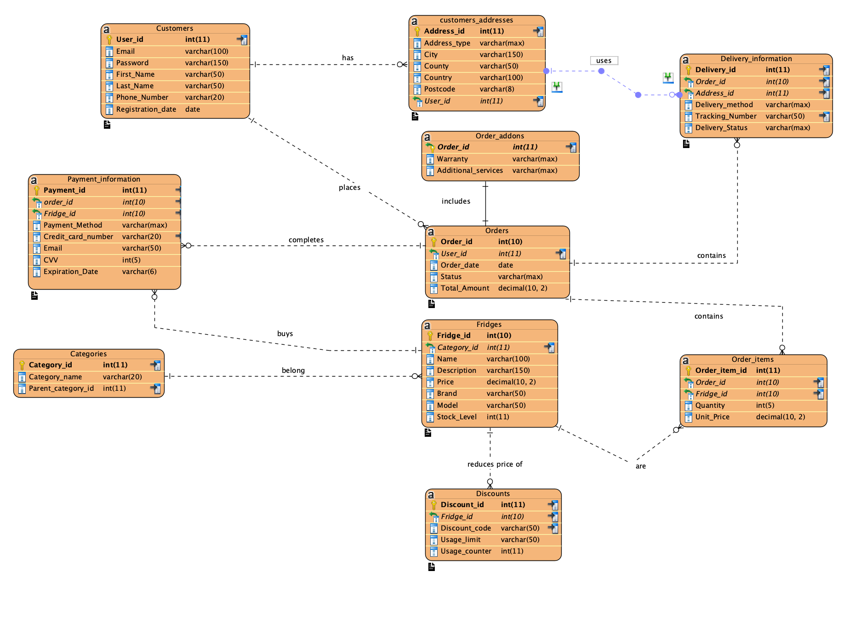

In this Extended Entity-Relationship Model (EERM) shown above, the diagram intricately outlines the database architecture of an e-commerce platform that specializes in the sale of refrigeration appliances. The model uses a range of entities, each with specific attributes that define its properties and several relationships that connect these entities, demonstrating the complex interplay of data within the system (Connolly & Begg, 2014).

Entities such as Customers, Addresses, Orders, Order_items, Fridges, Categories, Discounts, Payment_Information, Delivery_Information, and Order_addons form the core components of the database, with their attributes ranging from identification keys like User_id and Order_id to descriptive data such as Description and Brand for the Fridges entity. The relationships are defined by keys, where primary keys serve as unique identifiers for entity instances, and foreign keys link entities together, creating a network of interconnected data (Elmasri & Navathe, 2015).

The use of extended notations such as aggregation — depicted by the diamond shape connecting Orders to Order_items — denotes a stronger relationship where Order_items are logically dependent on Orders for their existence (Coronel & Morris, 2016). The crow's foot notation illustrates one-to-many and many-to-many relationships, indicating the cardinality between entities, a fundamental aspect of database design that dictates how instances of one entity relate to instances of another (Date, 2003).

Specialization or categorization is implied through the potential for entities like Customers to have subtypes, indicating a hierarchy and inheritance within the entity class (Silberschatz, Korth, & Sudarshan, 2010). This allows for extended attributes and roles for different customer types, which can be critical for business logic and marketing strategies.

In maintaining data integrity and optimizing query performance, attributes are marked as unique where necessary, ensuring that data retrieval is efficient and that each record maintains its distinctiveness (Ramakrishnan & Gehrke, 2003).

In summary, the EERM diagram represents a sophisticated blueprint of the relational database, essential for the storage, retrieval, and management of data in e-commerce operations. The extended ER features provide a more nuanced representation of the database, crucial for complex applications that require detailed data analysis and management (Garcia-Molina, Ullman, & Widom, 2009).

## 2.2 Database Schema

The database schema presented below illustrates the logical structure of the database, delineating how data is stored, related, and retrieved, which is critical for ensuring the efficiency and integrity of the database system (Elmasri & Navathe, 2015).

In terms of **normalization**, the schema adheres to the principles of at least the Third Normal Form (3NF).Below is my resoning for how and why my fields have passed each normalization form.

1. **First Normal Form (1NF)** is achieved as each table has a primary key, and all attributes contain atomic values with no repeating groups. For example, the **Customers** table has a primary key **User_id**, and all other attributes like **Email**, **Password**, and **Phone_Number** are atomic and singular for each record (Connolly & Begg, 2014).
2. **Second Normal Form (2NF)** is met when a database is in 1NF and all non-key attributes are fully functionally dependent on the primary key. For instance, in the **Order_items** table, attributes like **Quantity** and **Unit_Price** are dependent on **Order_Item_id**, which is a composite key made of **Order_id** and **Fridge_id**. There are no partial dependencies of any attribute on a part of a primary key (Coronel & Morris, 2016).
3. **Third Normal Form (3NF)** requires the database to be in 2NF and that all transitive dependencies are eliminated. This means that no non-key attribute depends on another non-key attribute. The schema reflects this as, for example, **Payment_Information** has **Payment_id** as a primary key, and all other attributes like **Payment_Method** and **Credit_card_number** depend only on **Payment_id**, not on any other non-key attribute (Silberschatz, Korth, & Sudarshan, 2010).

Furthermore, the schema shows evidence of good design practices such as the use of foreign keys to establish referential integrity, as seen where **Order_id** in **Payment_Information** references **Order_id** in **Orders**. This ensures that only valid data that corresponds to existing orders can be entered into the **Payment_Information** table, which is an essential aspect of maintaining data consistency (Date, 2003).

In summary, the database schema exhibits a well-structured and normalized design that adheres to 3NF, which is critical for reducing redundancy, ensuring data integrity, and facilitating efficient data management within the e-commerce platform.

Below are the 10 tables along with their attributes that are going to be implemented.

* Customers (Table 5)
* Fridges(table6))
* Delivery_information (Table 7)
* Orders (Table 8)
* Order_items (table 9)
* Payment_information (Table 10)
* Customers_addresses (Table 11)
* Categories(Table 12)
* Categories((Table 13)
* Order_addons (Table 14)
* Discounts (Table 15)

|  |  |  |
| --- | --- | --- |
| **Customers** | | |
| **Attribute Name** | **Type** | **Description** |
| Email | Varchar(100) | Holds the email Address of customer, indexed |
| User_id | Integer (11) | Primary Key, indexed,unique |
| Password | Varchar(150) | Hold’s Customer password. Password is hashed and encrypted to protect customer info |
| First Name | Varchar(50) | Hold’s the customer first name |
| Last Name | Varchar(50) | Holds customer last name |
| Registration_date | Date | This holds the date of when the customer registered on the website |
| Phone Number | Integer(20) | Holds the phone number of customer |

|  |  |  |
| --- | --- | --- |
| **Fridges** | | |
| **Attribute Name** | **Type** | **Description** |
| Fridge_id | Integer(10) | Primary Key, Unique, auto generated for each fridge |
| Name | Varchar(100) | Holds the name of the fridge |
| Description | Varchar(150) | Holds a basic description of the fridge product |
| Price | Decimal(10,2) | Holds the base fridge’s price before any reductions or increases |
| Brand | Varchar (50) | Holds the fridge manufacturer |
| Model | Varchar(50) | Holds the fridge make |
| Stock_level | Integer(11) | Holds the current stock left to sell for each fridge, Indexed |

|  |  |  |
| --- | --- | --- |
| **Delivery_information** | | |
| **Attribute Name** | **Type** | **Description** |
| Delivery_id | Integer(11) | Primary Key, Unique, Indexed. Used to uniquely identify each delivery that has been issued |
| Order_id | Integer(11) | Foreign Key(Orders Table), Unique, Indexed |
| Address_id | Integer(11) | Foreign Key(customer_addresses), unique, Indexed |
| Delivery_method | Enum(Standard,’Express’, ‘Next-Day’ , Same-Day’) | Holds the type of delivery that has been requested by the customer |
| Tracking_number | Varchar(50) | Unique field that stores the tracking number of each delivery from the courier |
| Delivery_Status | Enum(‘Successful’ , ‘Unsuccessful, ’In transit’) | Stores the progress of the delivery. |

|  |  |  |
| --- | --- | --- |
| **Orders** | | |
| **Attribute Name** | **Type** | **Description** |
| Order_id | Int(11) | Primary Key,indexed, automatically issued |
| User_id | Integer(11) | Foreign Key, Indexed |
| Order_date | Date/time | Holds the date of when the customer placed the order |
| Status | Enum(Successful,Unsuccessful,pending) | Holds the order status of the customer i.e successful, unsuccessful ,etc |
| Total_amount | Decimal (10,2) | Stores the total Price of order including any add-ons and/or deliver prices |

| **Order_items** | | |
| --- | --- | --- |
| **attribute Name** | **Type** | **Description** |
| Order_item_id | Integer(11) | Primary Key, Indexed, Unique |
| Order_id | Integer(11) | Foreign key (Order Table), Indexed |
| Fridge_id | Integer(11) | Foreign Key (Fridges Table), Indexed |
| Quantity | Integer(5) | Holds a numerical value of the number of items ordered |
| Unit_price | Decimal(10,2) | Holds the price for 1 for each fridge purchased |

|  |  |  |  |
| --- | --- | --- | --- |
| **Payment_information** | | | |
| **Attribute Name** | **Type** | **Description** |
| Payment_id | Integer(11) | Primary key, Unique, Indexed. |
| Order_id | Integer | Foreign key (Orders Table), unique |
| Fridge_id | Varchar(150) | Foreign Key (Fridge Table ), unique |
| Payment method | Enum (Credit card , credit, Paypal) | Stores the payment method used by customer |
| Credit_card_number | Varchar(20) | Hold the Credit card number registered to user |
| Email | Varchar (50) | Holds the customers email address |
| CVV | Int(5) | Holds the customer’s card CVV |
| Expiration_Date | Varchar(6) | Holds the customers card expiration date |

|  |  |  |
| --- | --- | --- |
| **Customers_addresses** | | |
| **Attribute Name** | **Type** | **Description** |
| Address_id | Integer (11) | Primary key. Unique |
| User_id | Integer(11) |  |
| Address_type | Enum(‘Billing , Delivery) | Stores what type of address has been stored. |
| Address_city | Varchar(50) | Stores the customer’s City |
| County | Varchar(50) | Stores the customer’s County |
| Country | Varchar(100) | Stores the customer’s country |
| Postcode | Varchar(6) | Stores the customer’s post code, Indexed, |
|  |  |  |

|  |  |  |
| --- | --- | --- |
| **Categories** | | |
| **Attribute Name** | **Type** | **Description** |
| Category_id | Int(11) | Primary key, unique. This row serves as the unique identifier to each category |
| Category_name | Varchar(20) | Stores the category name |
| Parent_category_id | Int(11) | Foreign key, unique |

|  |  |  |
| --- | --- | --- |
| **Order_addons** | | |
| **Attribute Name** | **Type** | **Description** |
| Order_id | Int(11) | Primary key , unique, foreign key |
| Warranty | Enum(‘Yes’ , ‘No’) | Stores whether the customer has added warranty to their purchase |
| Additional_services | Enum('Gift Wrapping','Product insurance’, ‘Assembly Service','Customization','Subscription','Installation Service') | Stores any additional services the customer has opted for |

|  |  |  |  |
| --- | --- | --- | --- |
| **Discounts** | | | |
| **Attribute Name** | | **Type** | **Description** |
| Discount_id | Integer(11) | | Primary key, Unique used as identifier to link all the discount codes. |
| Fridge_id | Integer(11) | | Foreign Key (Fridge Table) |
| Discount_code | Varchar(50) | | Unique, this holds the registered discount codes |
| Usage_Limit | Varchar(50) | | Holds the limit for each code |
| Usage_counter | Int(11) | | Holds the number of times a discount code has been used |

# 3. Database implementation (10%)

The database for the envisioned system has been constructed using phpMyAdmin, specifically version   5.2.1 which is up to date. The fundamental database server employed is MariaDB, version 10.4.28- Source distribution, which is an open-source derivative of MySQL. Crafted by the original architects of MySQL, it is designed to remain open source. It is an important component of several cloud services and serves as the default in most Linux distributions. (MariaDB, 2019)

The figure below depicts all the tables used whilst creating this database. InnoDB is a storage engine that is efficient in its “performance” and “reliability”. Additionally , it is the default MariaDB storage engine. (MariaDB, 2023). All the tables have been filled using an auto generator called filldb.info. (FillDB,2023)

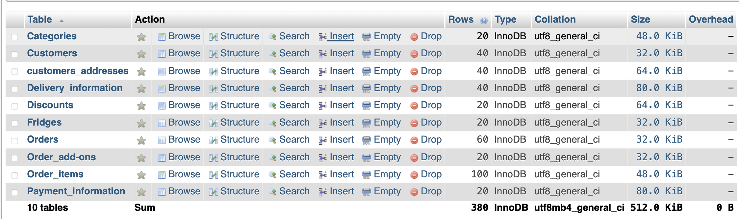

Figure 31: The table details of the envisioned database.

Some rows created for each table and the sql output of every table is shown below using screenshots from figure to. This has been done reduce clatter within the report and improve readability as some of the tables have too many rows to show within the screenshots.

Please note that these are in alphabetical order starting off with the Categories table and ending with the Payment_information table.

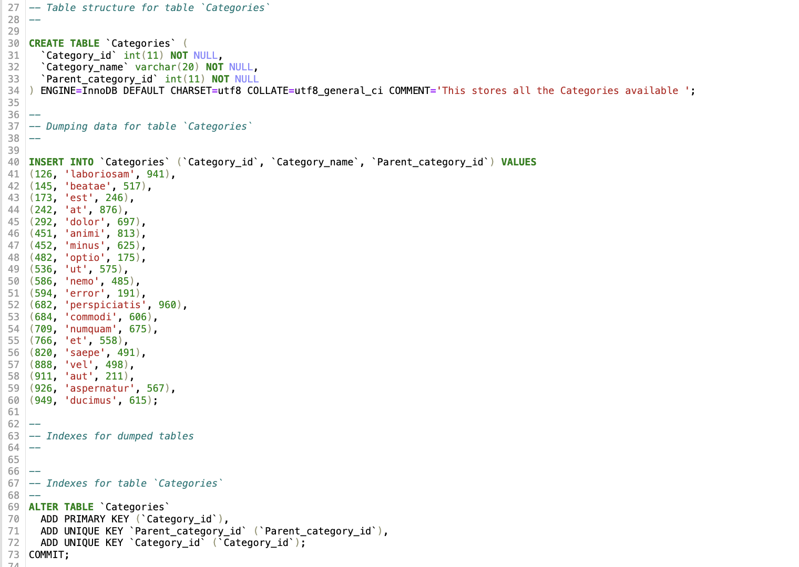

Figure 32: SQL output of the Categories Table

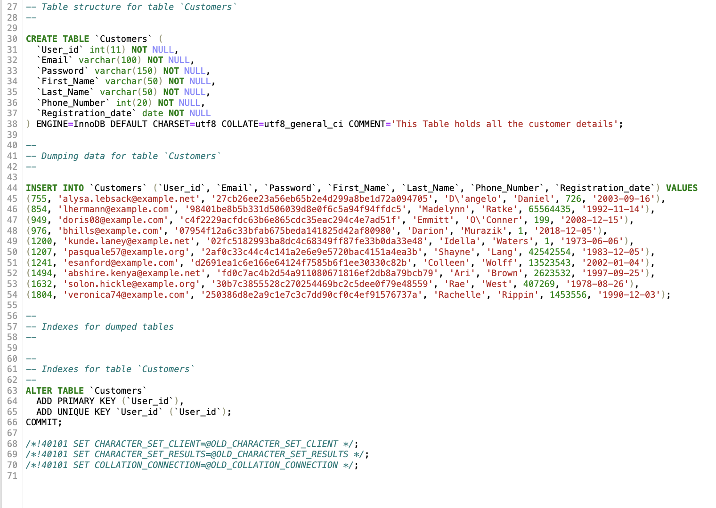

Figure 33 : SQL output of the Customers Table

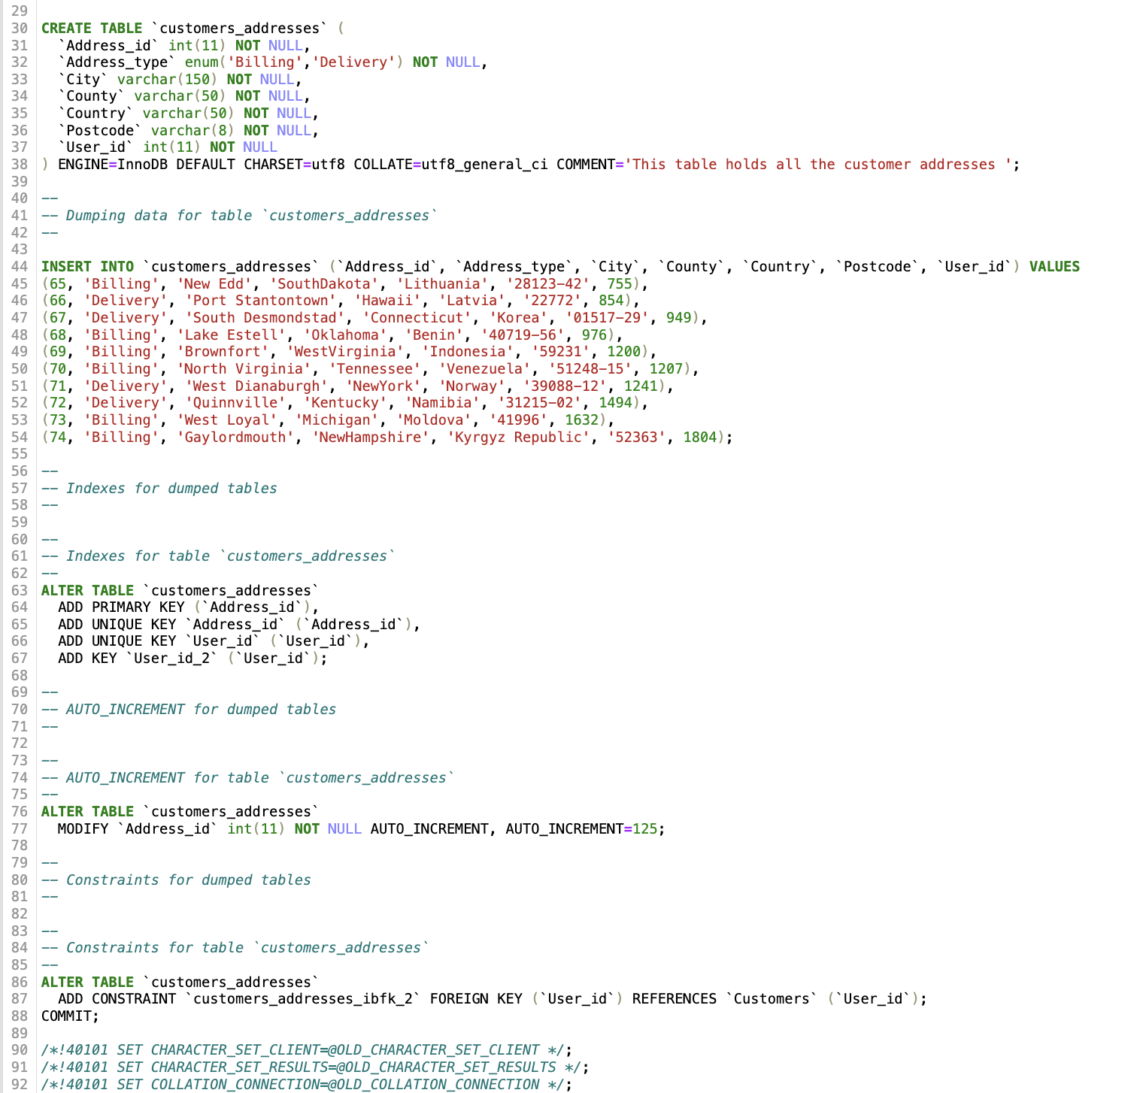

Figure34 : SQL output of the Customer_addresses Table

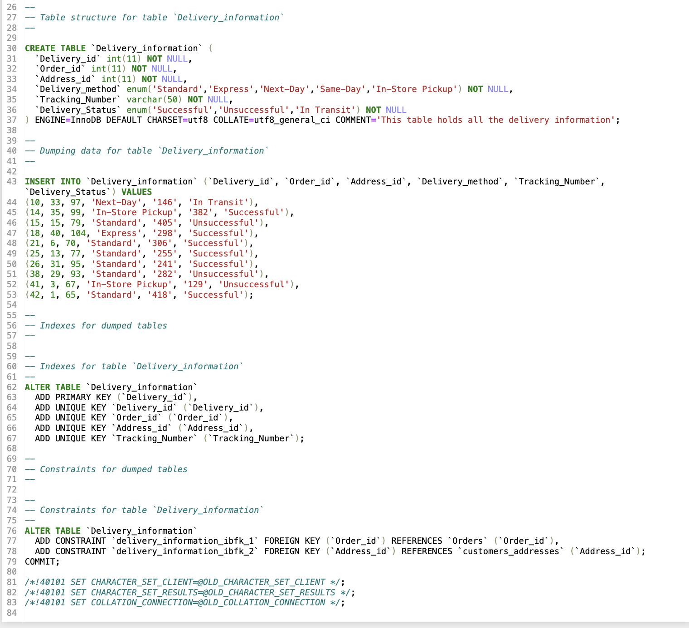

Figure 35: SQL ouput pertaining to the Delivery_information Table.

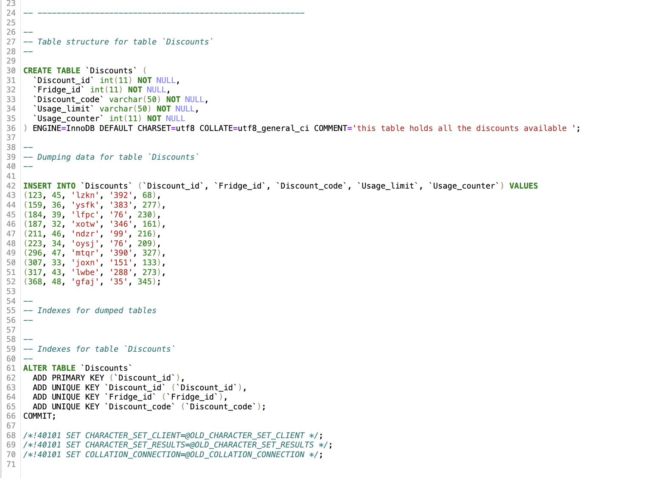

Figure 36 depicts the SQL output of the Discounts Table

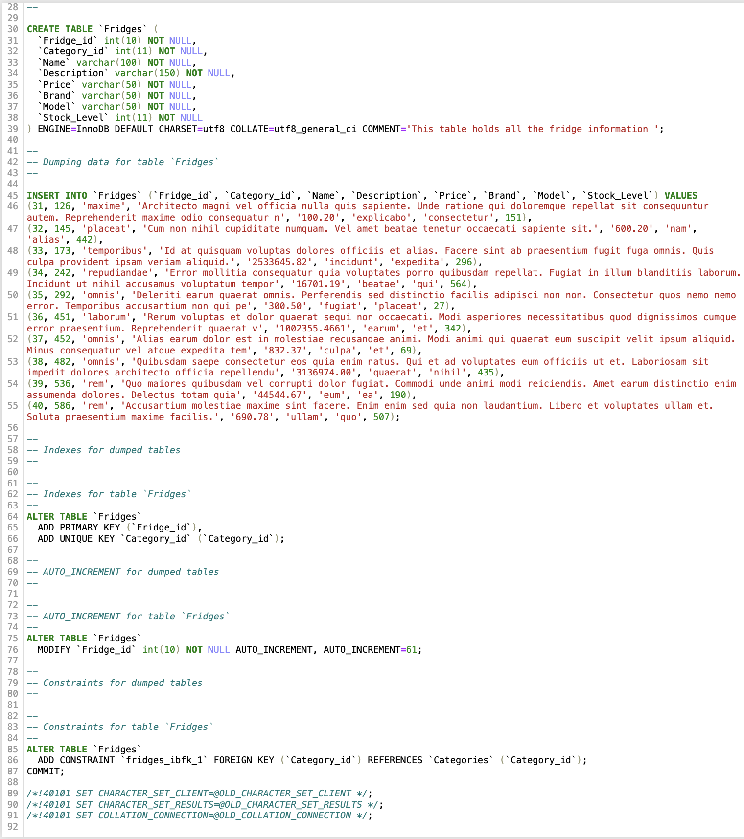

Figure 37: SQL output of the Fridges Table

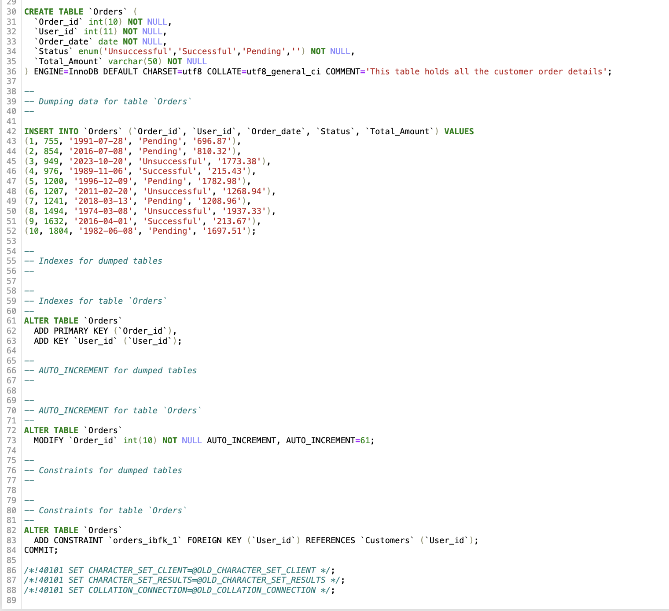

Figure 38 : SQL output of the Orders Table

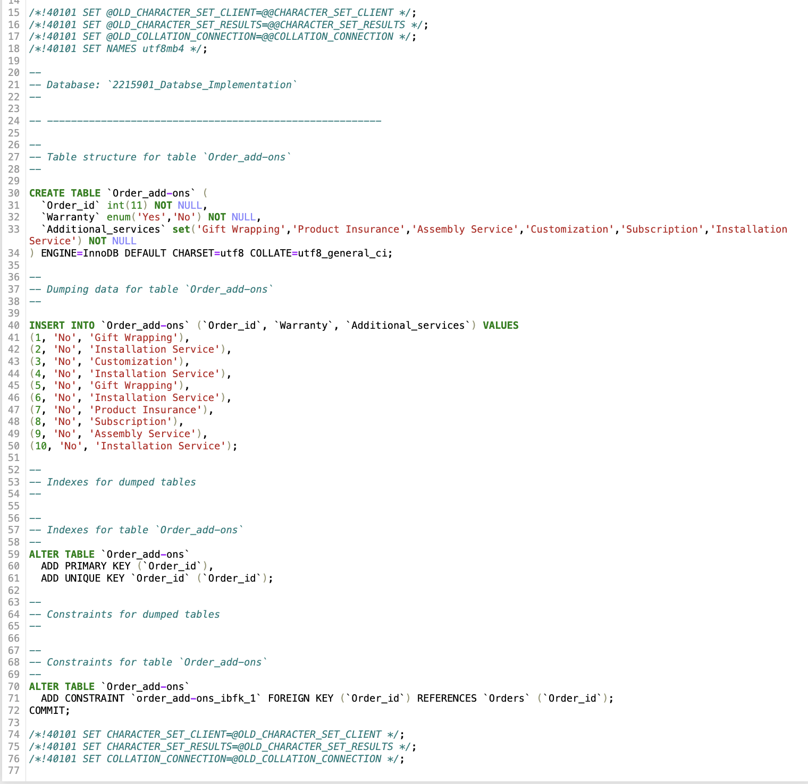

Figure 39 : SQL ouput of the Order_add-ons Table

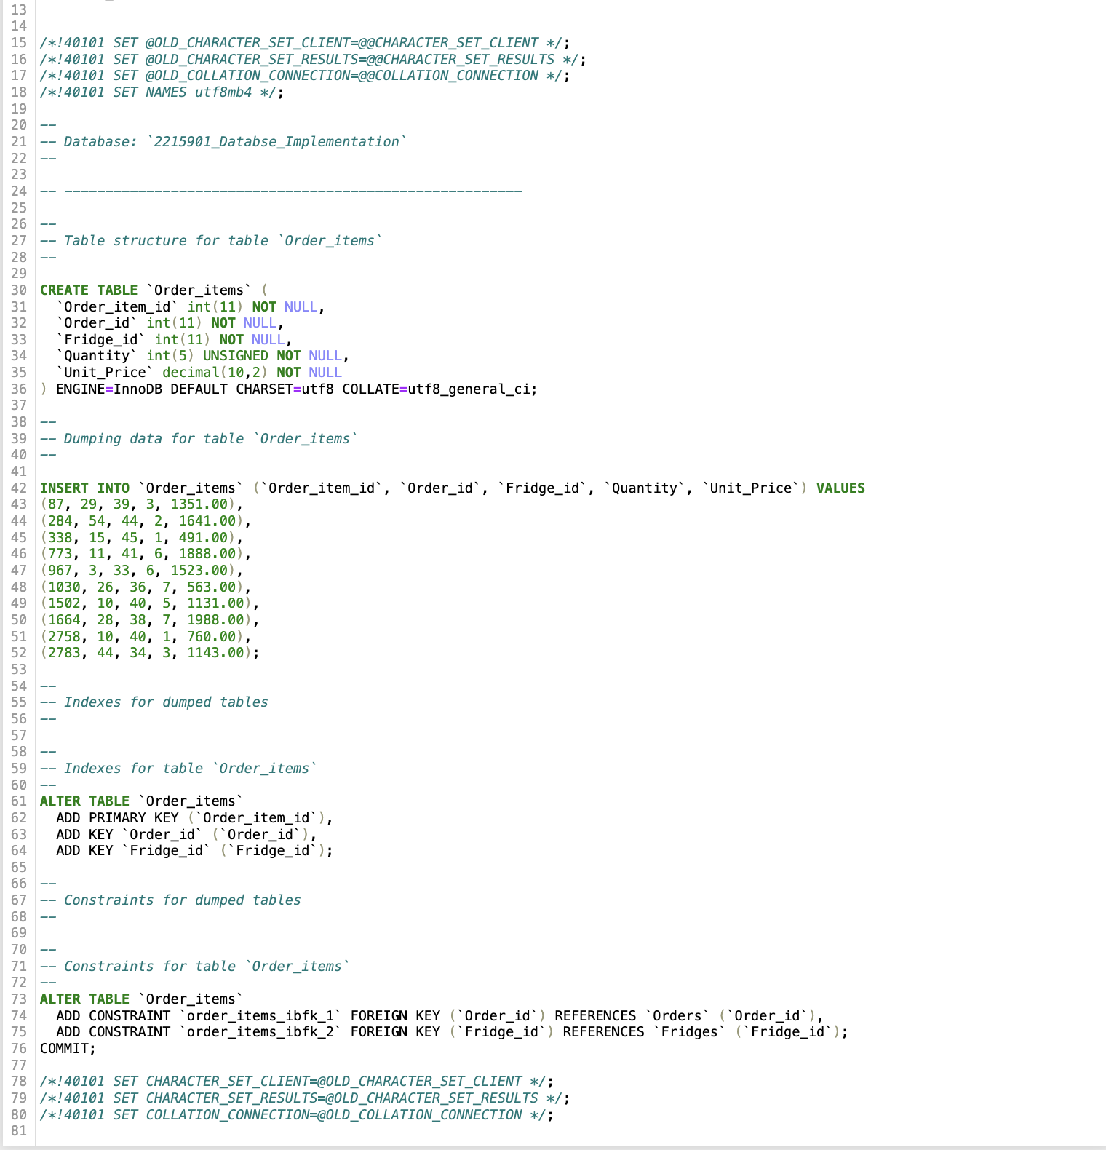

Figure 40: SQL output of the Order_items Table

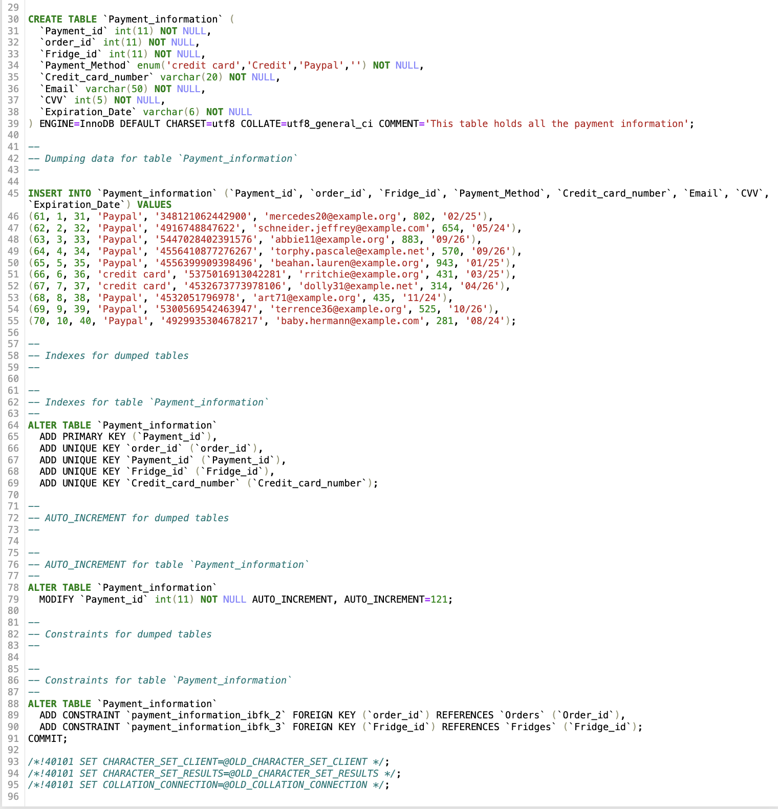

Figure 41: SQL output of the Payment_information Table

# 4. SQL Queries (50%)

## 4.1 Query 1

### 4.1.1 For what purpose will this query be used in business terms?

### 4.1.2 Query in natural language

This query will first find all the unsuccessful deliveries done. After having done so, the next process is retrieving the full 44.

customer name, email, tracking number , and telephone number along with the corresponding country code to reach out to the customer.

### 4.1.3 SQL Code and output

Firstly, a new table is created using the countries from the customer _addresses table to populate this table. This is done using two separate sql codes. The first sql below is to populate the first column CountryName.

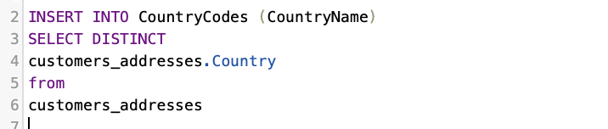

To be able to populate the second column, I had to allow for the country code to have null values. This is shown later below. The reasoning behind this was to be able to edit the second column country_code using the second sql code.



This figure shows one of the records after executing the first sql code.

The second phase is shown below. The country code values have been gathered using a country code finder. (countrycode.org, n.d.)

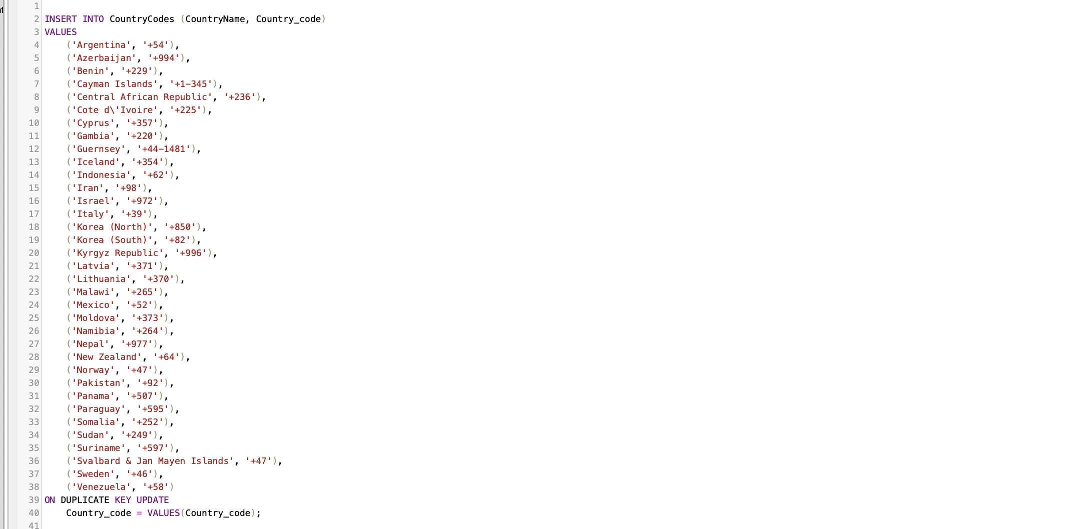

To be able to update the rows and avoid duplicate countries, I have made the CountryName a primary key. This allowed me to replace the null values with the country codes.

After executing this query, it produced the results shown below.

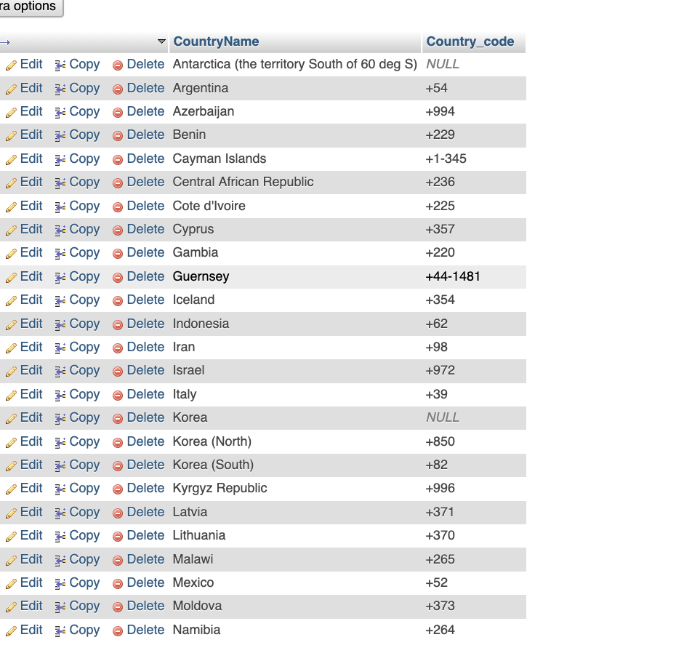

Please note that the null values have been later replaced with dummy values.

After creating this table, the next step is to execute the main sql which will output the desired data.

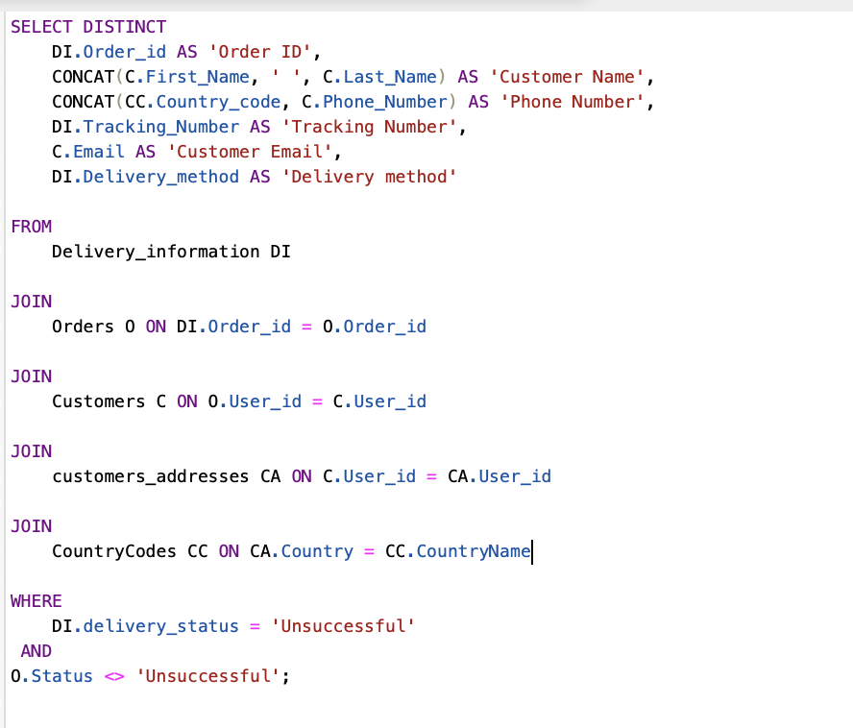

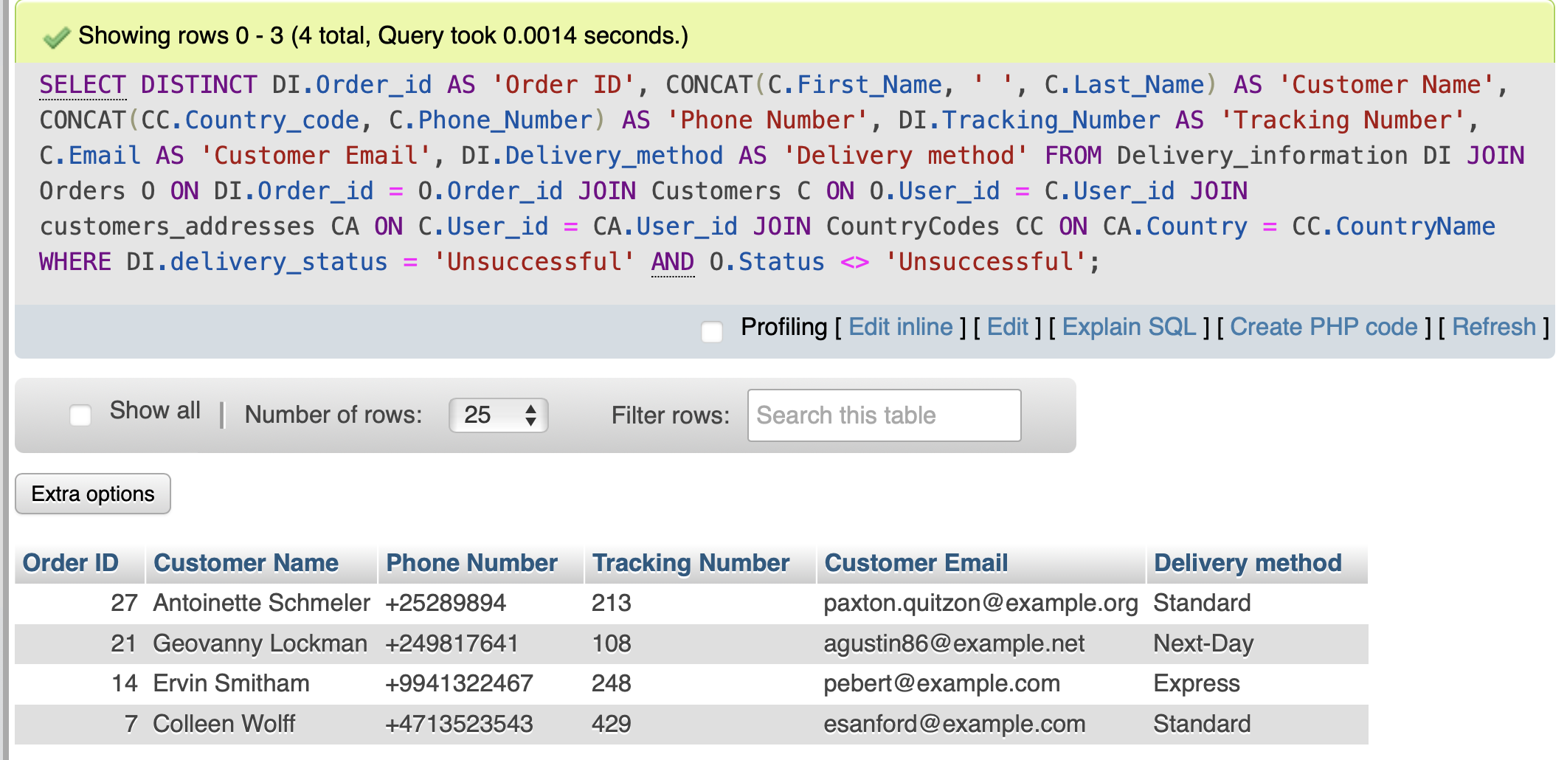

### 4.1.4 Explain the output of the data (was this what was predicted?)

The query executed the Author’s desired outcome. In total there are 7 unsuccessful deliveries but 4 in total where the order has been processed or pending which means that the payment has gone through. This in turn shows the correct information that can now be used to contact the relevant customers about their Orders as well as track the orders with the courier to notify the customer of any changes.

## 4.2 Query 2

### For what purpose will this query be used in business terms?

The query provided is designed to retrieve information about the top categories in terms of bought fridges, considering successful orders, and calculating the total sales for each category. In business terms, this query could be used for various purposes such as a Performance Analysis Identify the top-performing categories based on the quantity of bought fridges .Analyse total sales to understand revenue generation for each category.

### Query in natural language

This query will gather information about the top 3 best performing fridge categories based on the amount of bought fridges. The calculations involve counting the total quantity of fridges purchased, the total sales revenue (quantity multiplied by the unit_price) for each category, and to ensure that only successful orders are considered. The outputs that are to be displayed are the category ID, category name, total bought fridges, and total sales, including the pound symbol for sales currency."

### SQL Code and output

Figure 35 shows the SQL operations that are going to be used to construct the query, while Figure 36 shows its output.

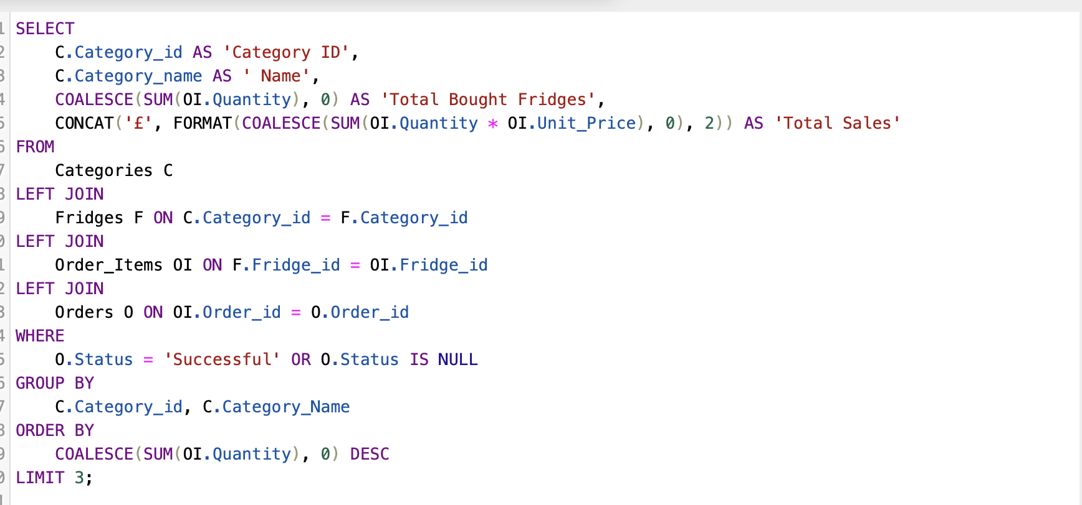

The figure below shows the output of the above SQL code.

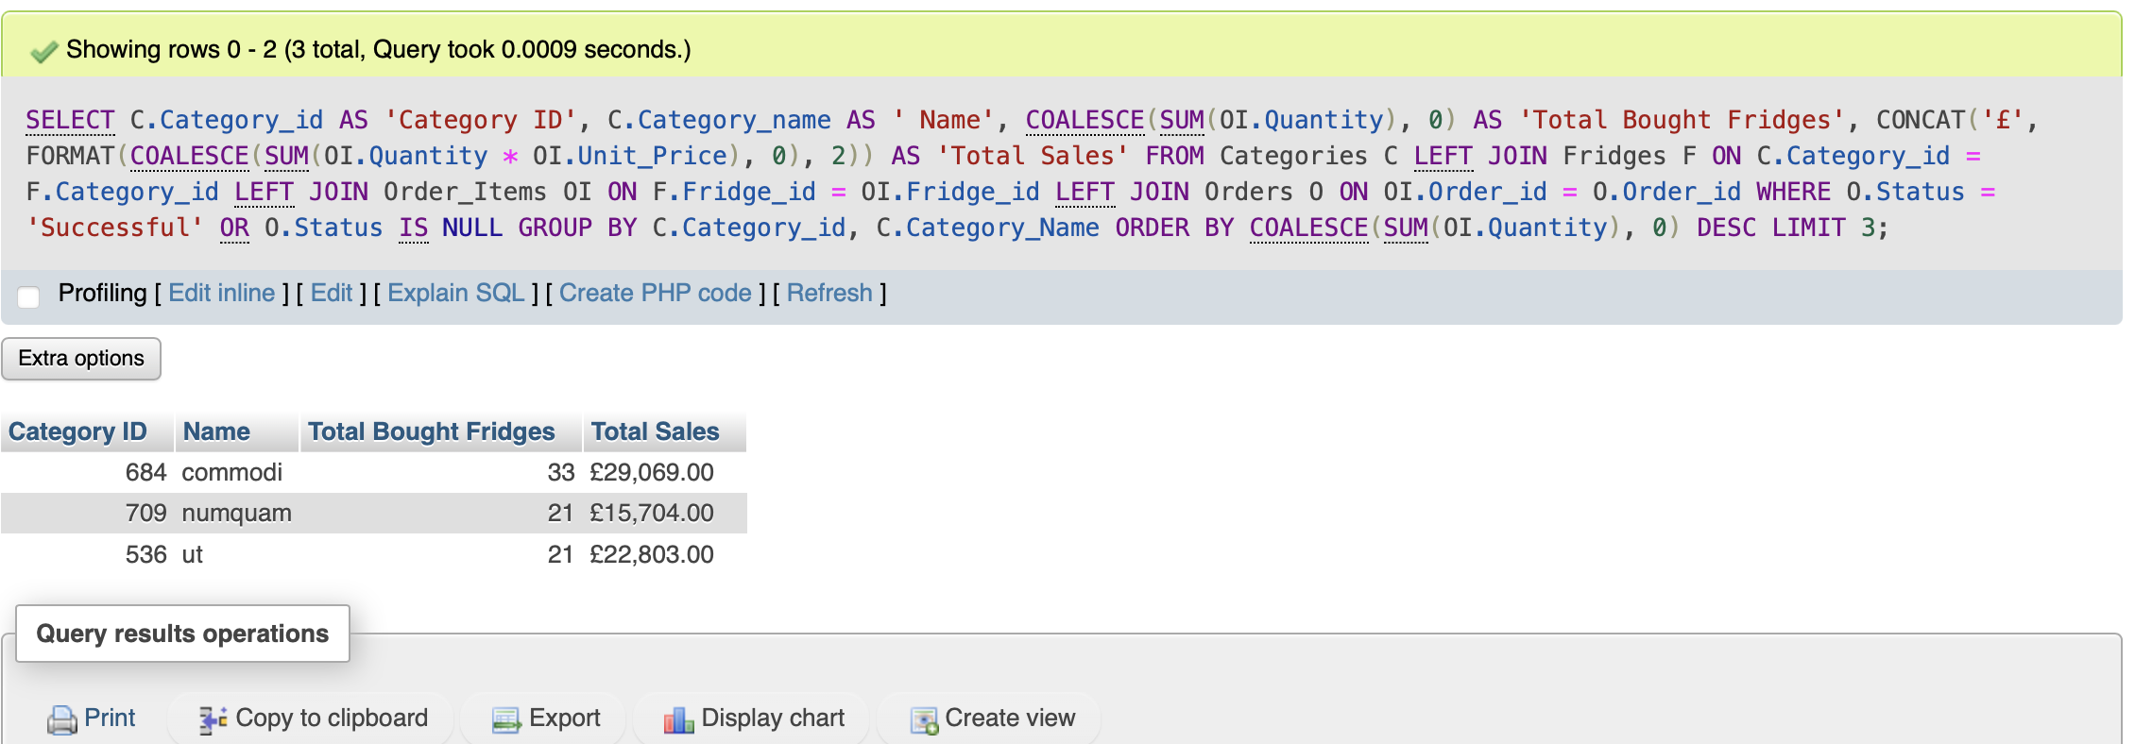

### 4.2.4 Explain the output of the data (was this what was predicted?)

The result of this query is as expected . The author can use this information to either increase the stock levels of each fridge or issue out a new discount code through email to encourage even more purchases for the popular fridges.

## 4.3 Query 3

### 4.3.1 For what purpose will this query be used in business terms?

For this query the main use is to find and reward the high value customers that have played a quintessential role in the success of the business. These high value customers include those that have enrolled in a subscription offered to the customers as an add-on and the customers that contribute significantly to the revenue of the company. Once received the names can be sent to the Marketing Department to issue out discount codes or to send a complimentary gift in the future.

### 4.3.2 Query in natural language

Display the top 5 customers that have spent the most money over the years and the customers that have enrolled to a subscription that notifies them of any deals or discounts.

### 4.3.3 SQL Code and output

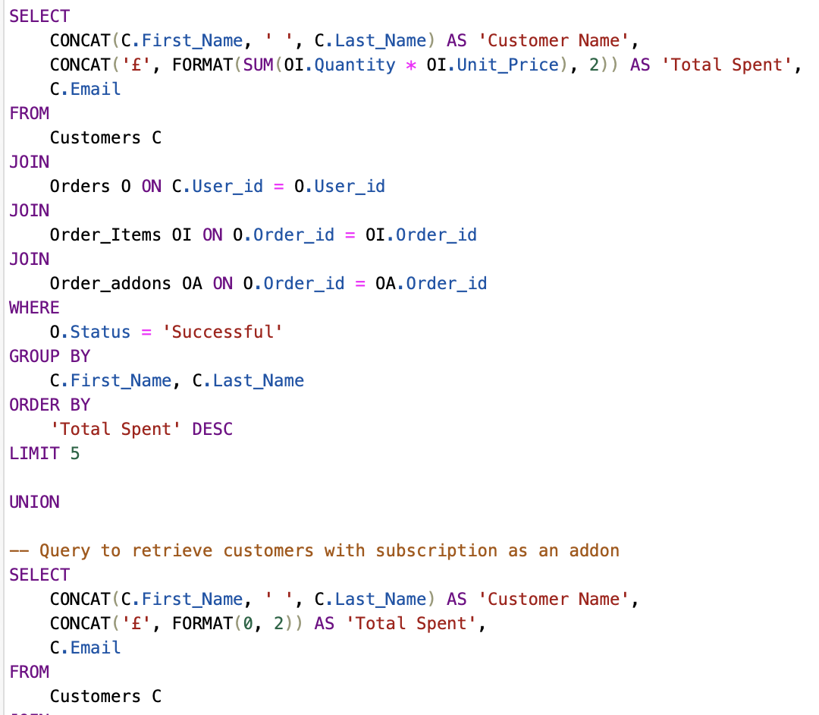

These two figures illustrate the SQL command used to produce the query.

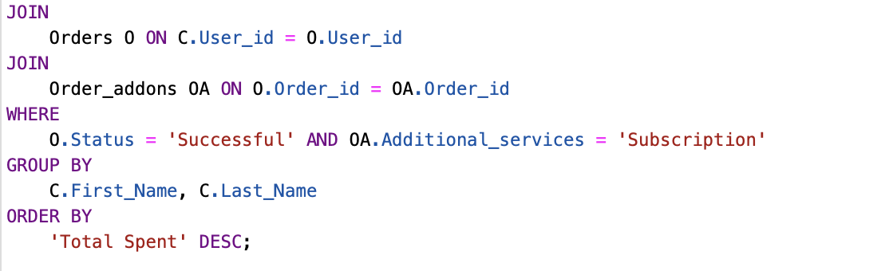

These two figures illustrate the SQL command used to produce the query.

This screenshot directly underneath shows the output produced from running the SQL command.

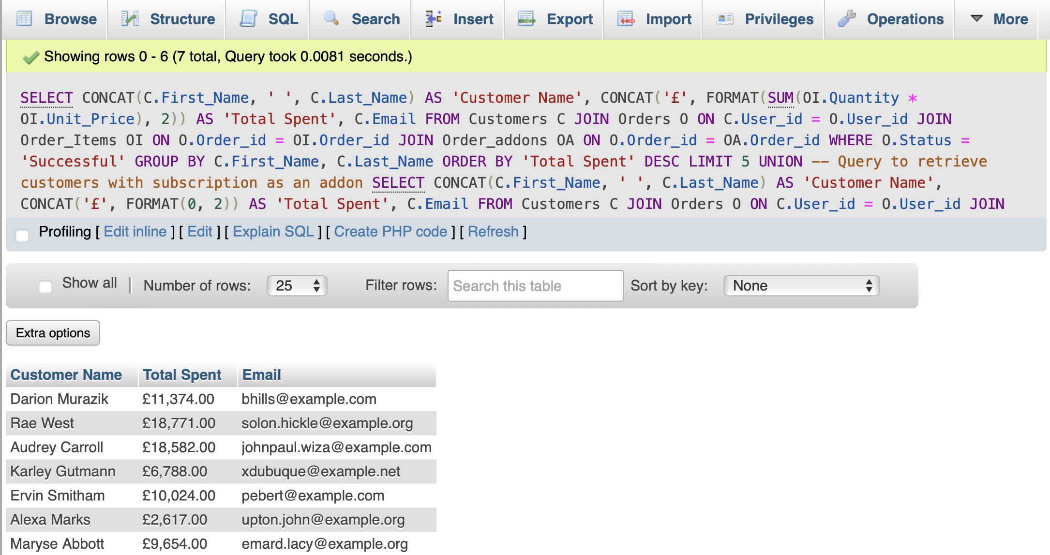

### 4.3.4 Explain the output of the data (was this what was predicted?)

## 4.4 Query 4

### For what purpose will this query be used in business terms?

The query to create this view for the unsuccessful deliveries and orders serves a business purpose by consolidating a unique set of records that represent both unsuccessful deliveries and unsuccessful orders. An analysis of unsuccessful Transactions can provide businesses with the ability to analyse and understand the common factors or issues contributing to unsuccessful deliveries and orders. This can help improve operational processes, customer satisfaction, and overall business performance. Additionally, businesses can use this information to communicate effectively with customers who experienced issues with their deliveries or orders. Proactive communication and problem resolution can enhance customer relationships and loyalty.

### Query in natural language

This query will search through the orders Table for any unsuccessful orders which means that the payment method has not been accepted. This is displayed in the form of a view which is saved with the tables is combined with any unsuccessful deliveries made. This information is retrieved from the Delivery_information Table. The final view should output the two combined select query results.

### 4.4.3 SQL Code and output

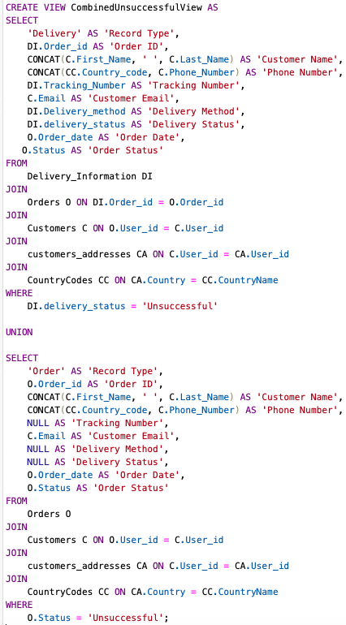

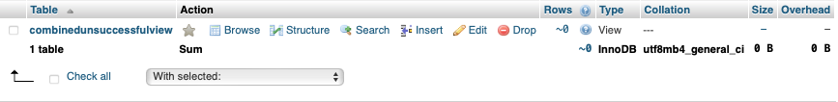

This figure above shows the view created after running the SQL query.

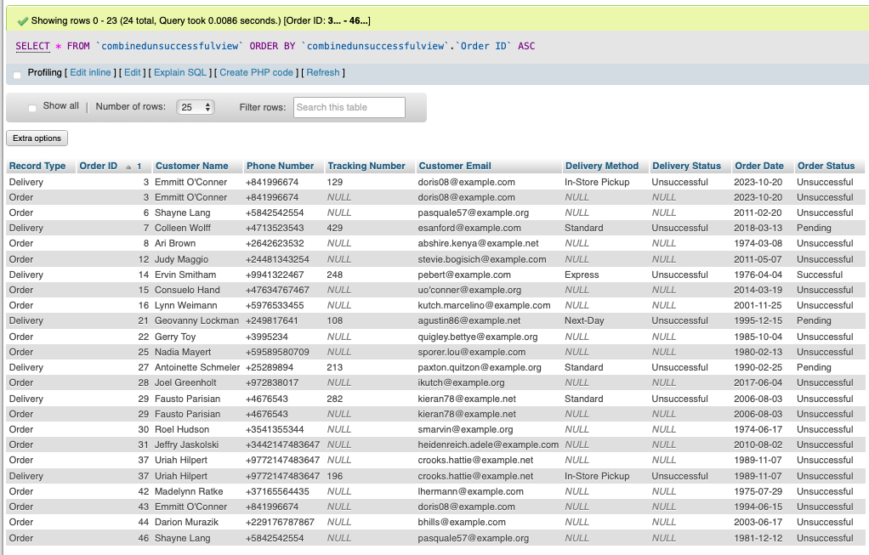

The figure above illustrates the view output after running the query which is then sorted order ID to identify any repeated records.

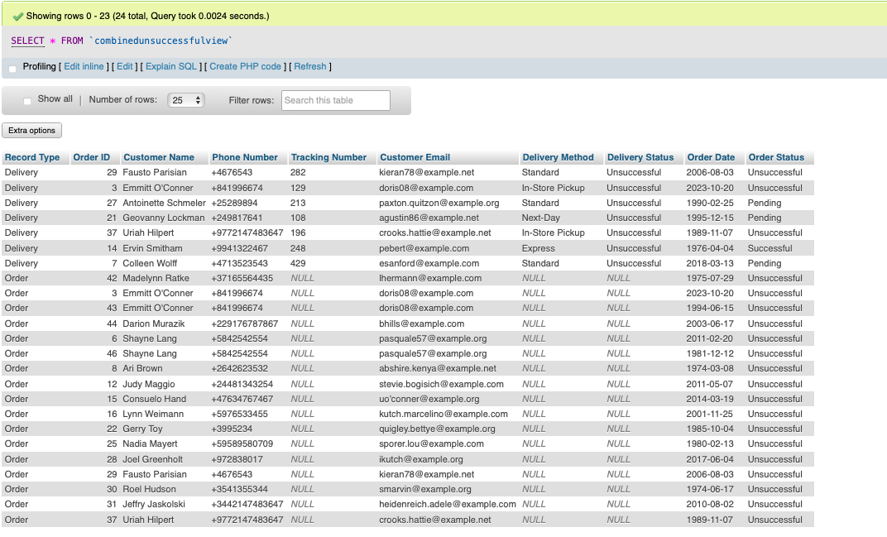

The figure above illustrates the view output after running the query.

### 4.4.4 Explain the output of the data (was this what was predicted?)

The data produced from the query is as expected barring the duplicate record. The desired outcome would have shown 23 records instead of 24 rows. This however does not hinder the effectiveness of the view as the duplicate record can easily be seen through the sorting of the order_id.

## 4.5 Query 5

### 4.5.1 For what purpose will this query be used in business terms?

The query and function provided underneath are designed to retrieve the total revenue for a specific fridge. The total revenue for a specific fridge contributes to financial reporting. This will allow businesses to track the performance of individual products and make informed decisions about inventory, pricing, and marketing strategies.

### 4.5.2 Query in natural language

Firstly, the Author will create a view that will show the gross sales have been successful throughout the years for each fridge. The three columns to be displayed are Fridge ID, Fridge name and the total revenue calculated by multiplying the fridge price by the number of fridges bought per order.

### 4.5.3 SQL Code and output

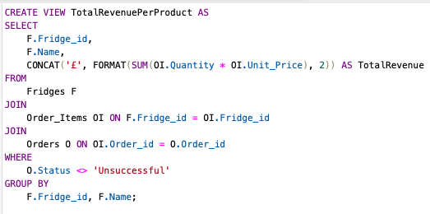

The figure above represents the code used contruct the view.

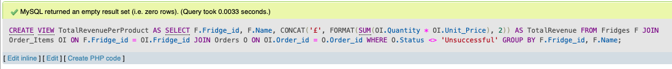

This figure shows the result after running the sql query meaning that it was successful.

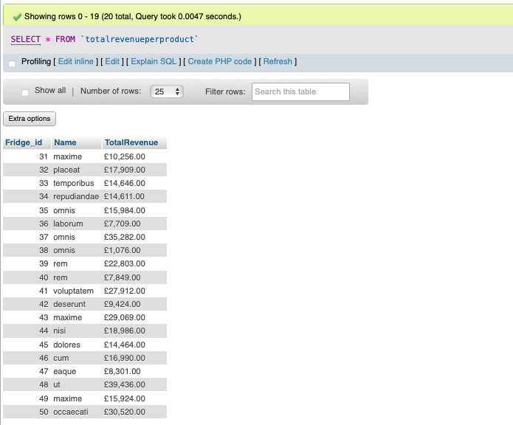

This figure above shows the view output from running the query.

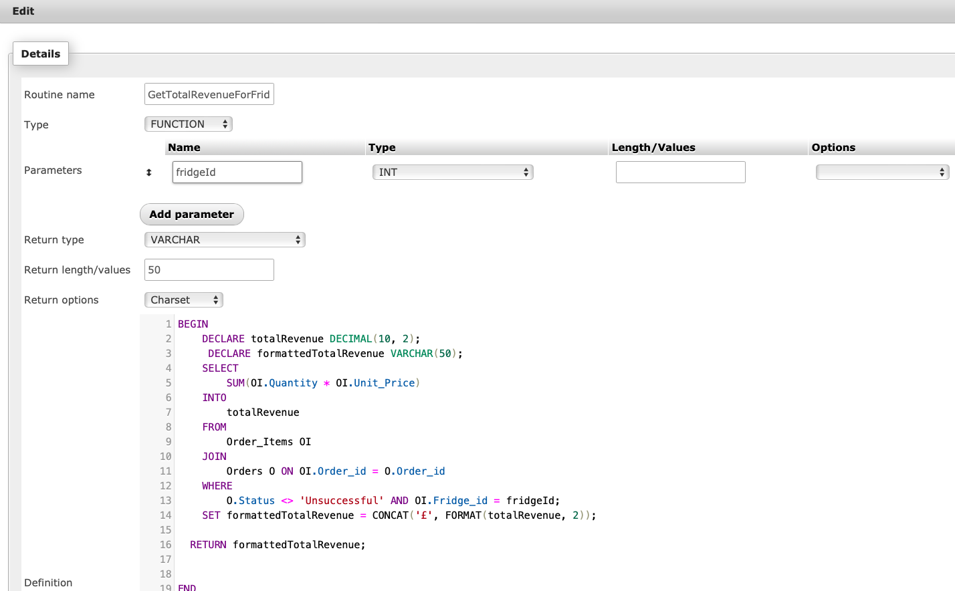

The screenshot above outlines the SQL code used to create the function that can be called whenever needed.

The screenshot here demonstrates the successful execution of the function when run to retrieve the correct data.

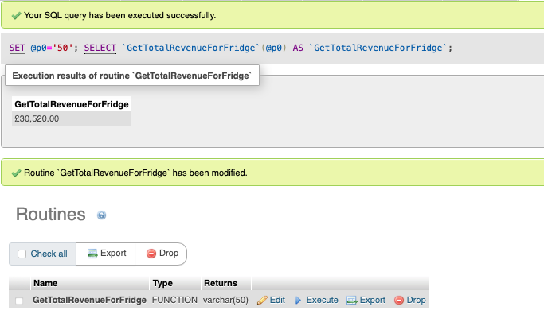

### 4.5.4 Explain the output of the data (was this what was predicted?)

The results from the view and stored function are expected as the results produced are accurate and identical. The view shows the general list for all fridges as desired, and the function can be called without any errors to retrieve the total revenue for each fridge registered.

# 5. References

MariaDB (2019) *MariaDB foundation*, *MariaDB.org*. Available at: https://mariadb.org/ (Accessed: 17 November 2023).

MariaDB (2023). *InnoDB*. [online] MariaDB KnowledgeBase. Available at: <https://mariadb.com/kb/en/innodb/>.

countrycode.org. (n.d.). *Country Codes, Phone Codes, Dialing Codes, Telephone Codes, ISO Country Codes*. [online] Available at: https://countrycode.org

‌ Simplilearn. (n.d.). *IKEA Marketing Strategy 2024: A Case Study*. Available at: [https://www.simplilearn.com](https://www.simplilearn.com/)

Connolly, T., & Begg, C. (2014). Database Systems: A Practical Approach to Design, Implementation, and Management (6th ed.). Pearson.

Elmasri, R., & Navathe, S. B. (2015). Fundamentals of Database Systems (7th ed.). Pearson.

Coronel, C., & Morris, S. (2016). Database Systems: Design, Implementation, & Management (12th ed.). Cengage Learning.

Date, C. J. (2003). An Introduction to Database Systems (8th ed.). Addison-Wesley.

Silberschatz, A., Korth, H. F., & Sudarshan, S. (2010). Database System Concepts (6th ed.). McGraw-Hill.

Ramakrishnan, R., & Gehrke, J. (2003). Database Management Systems (3rd ed.). McGraw-Hill Higher Education.

Garcia-Molina, H., Ullman, J. D., & Widom, J. (2009). Database Systems: The Complete Book (2nd ed.). Pearson.

Connolly, T., & Begg, C. (2014). Database Systems: A Practical Approach to Design, Implementation, and Management (6th ed.). Pearson.

.